We log in to chameleon….
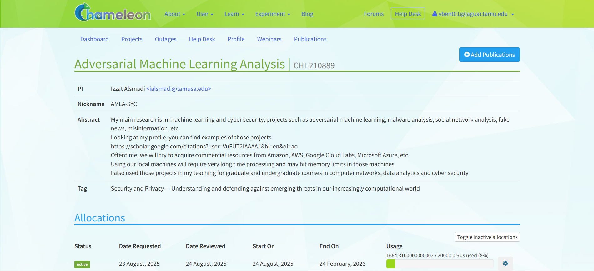

We go to Projects and select CHI@UC and we can see the dashboard

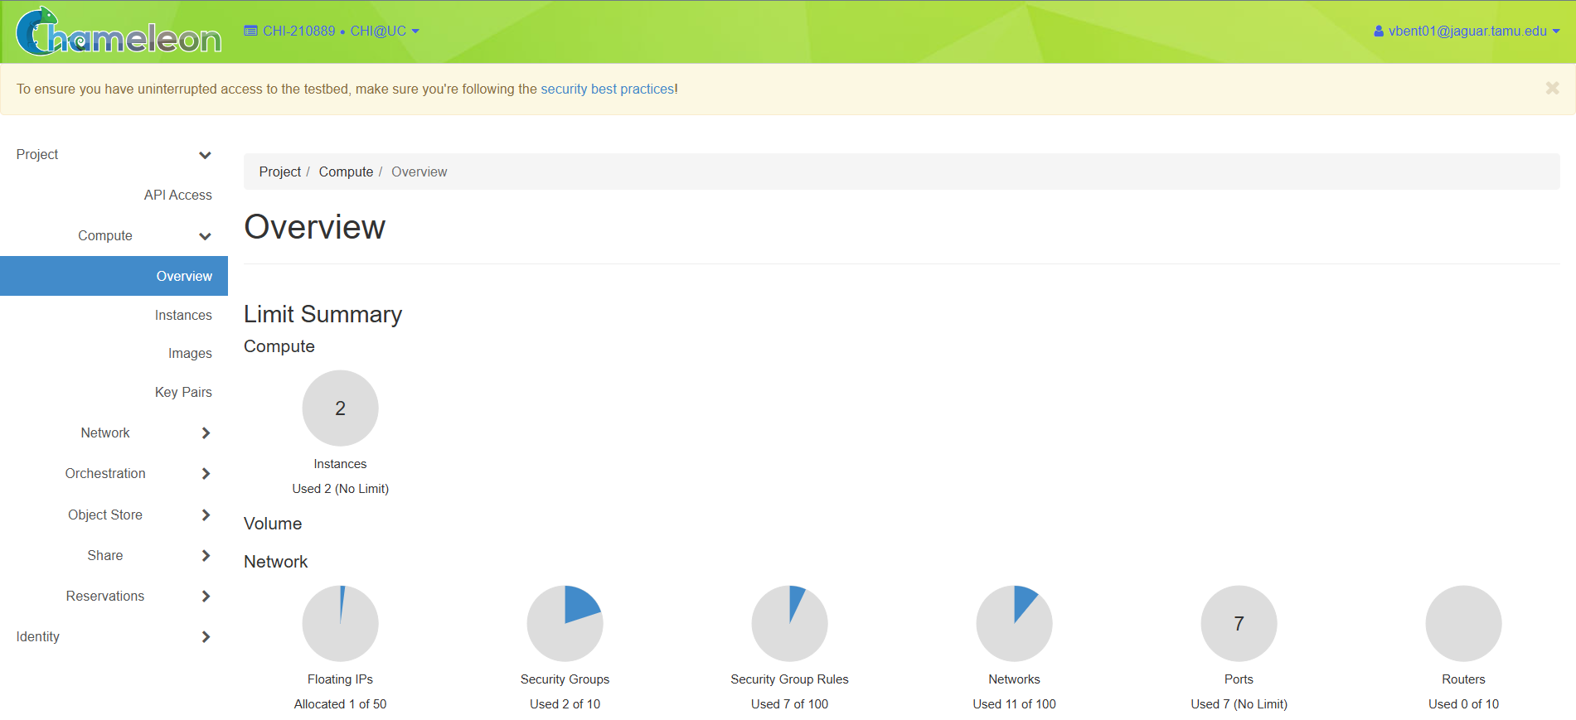

And first we create a Lease, we can do that in reservations sections and then Leases..
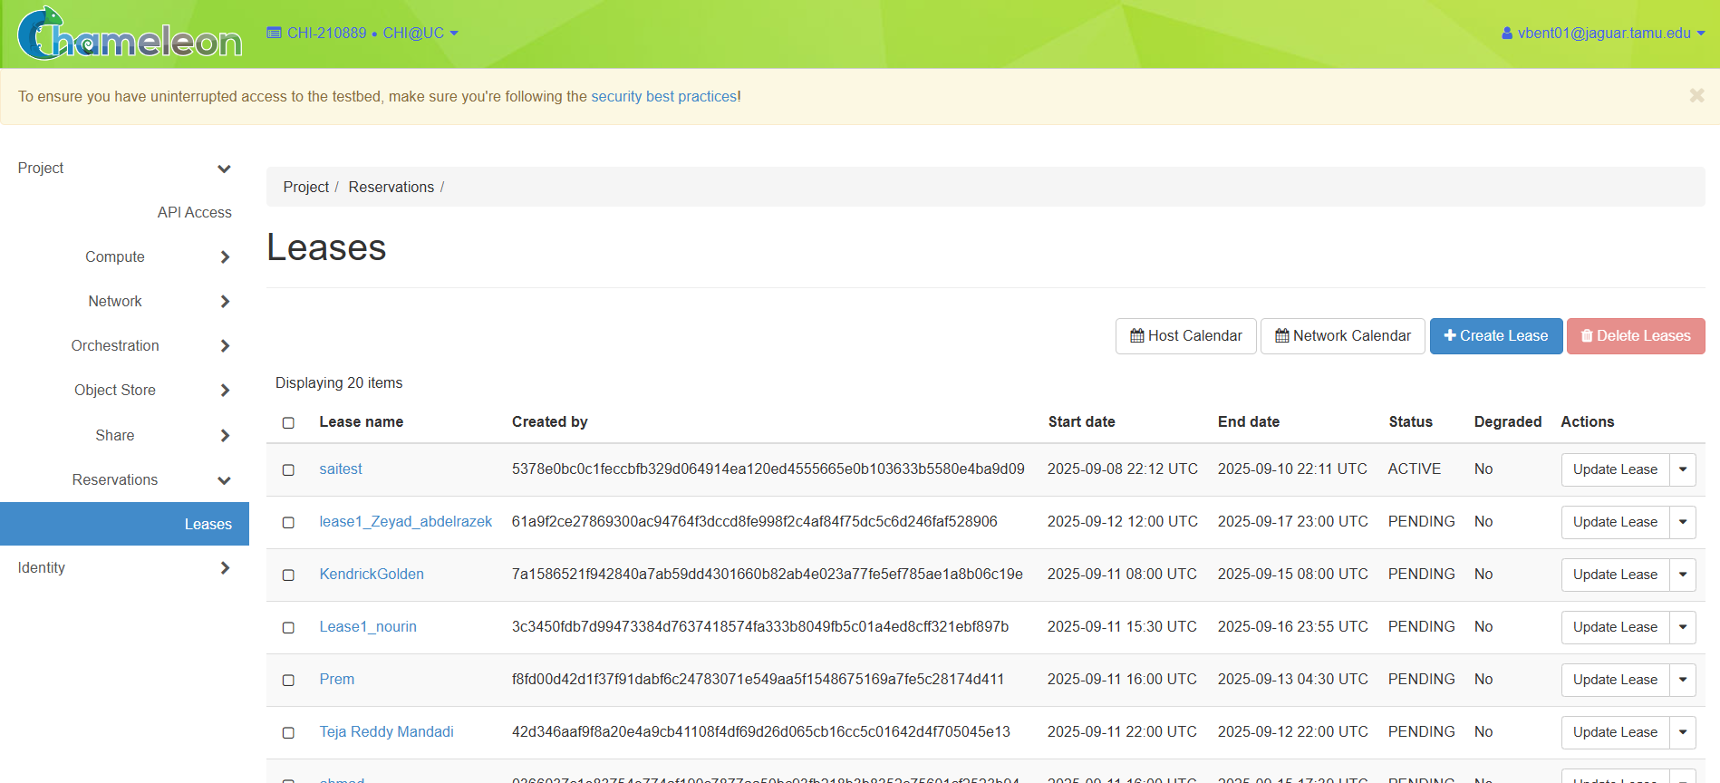
Then we can see a Create Lease window and do as per the manual suggests..
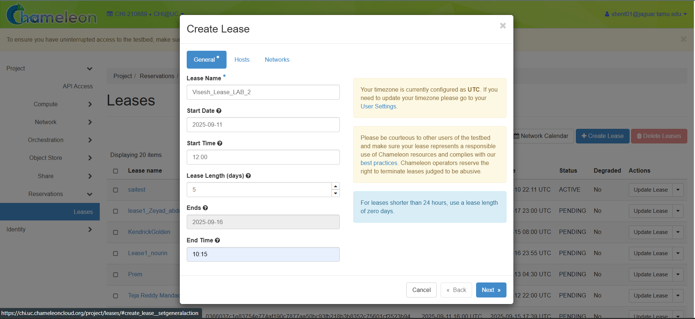

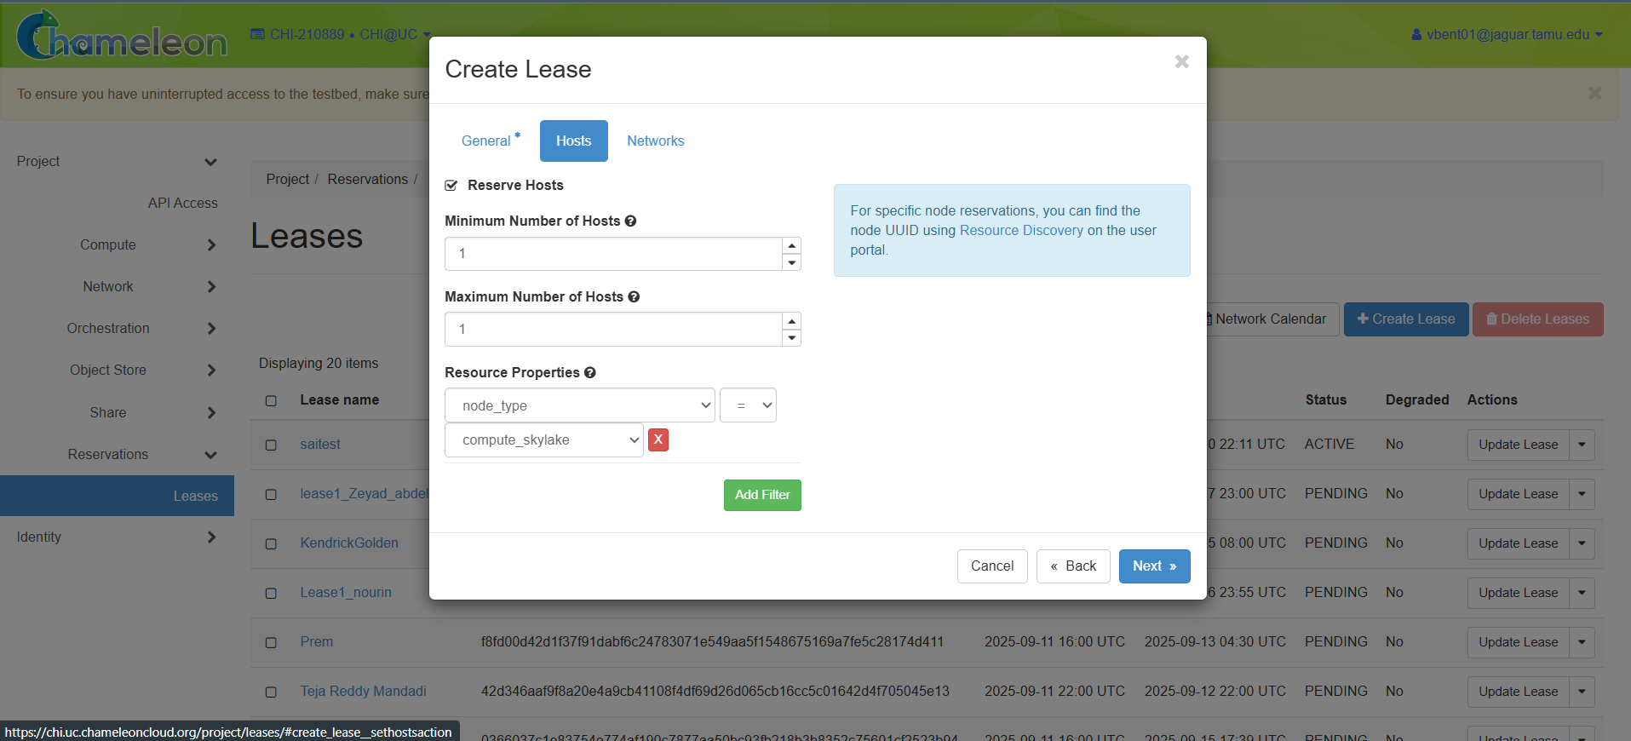
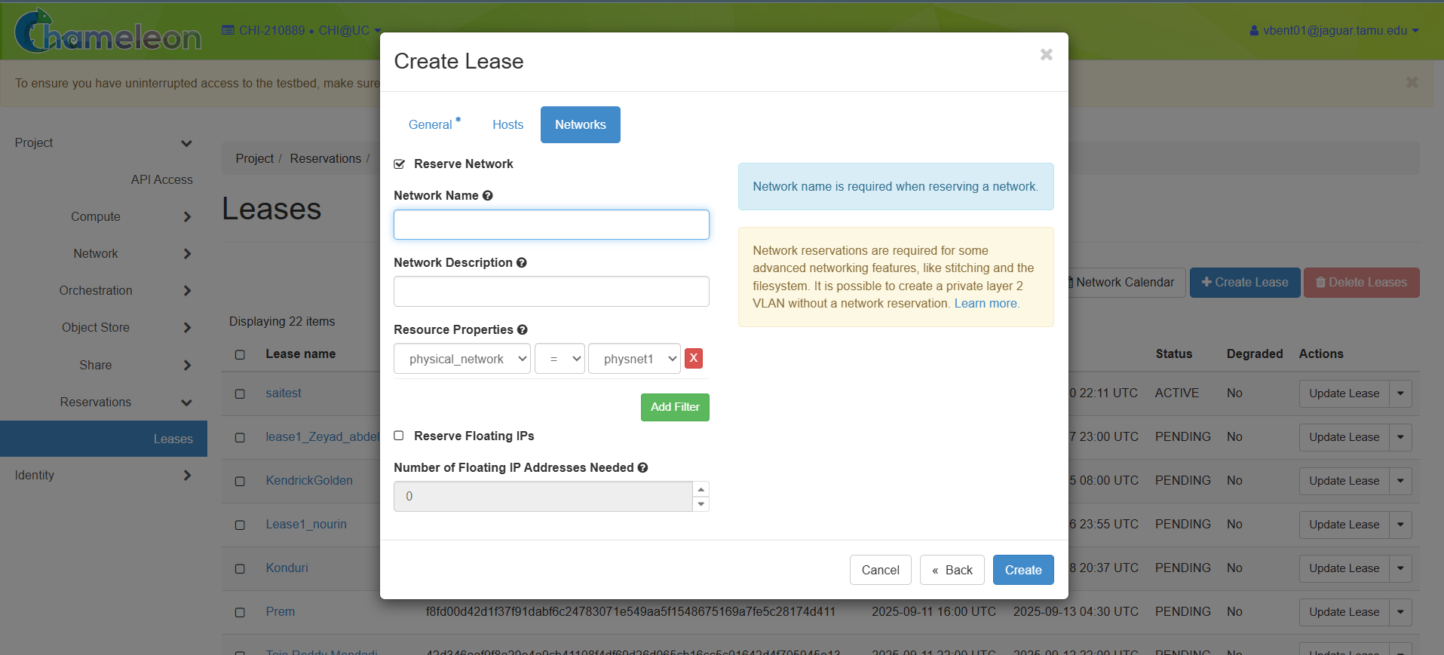
After Creating Lease successfully we go to the Leases section and check we got the lease or not?
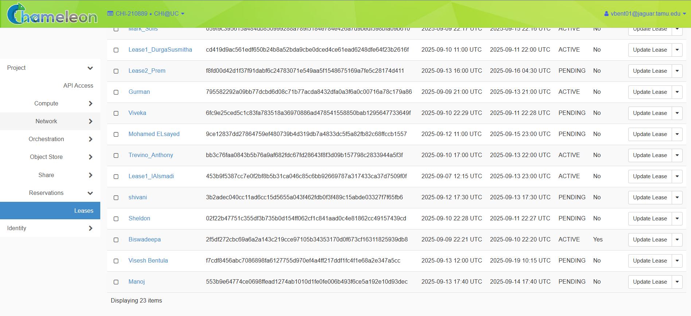
And then we must create a instance, we can do that by going to Compute -> Instances
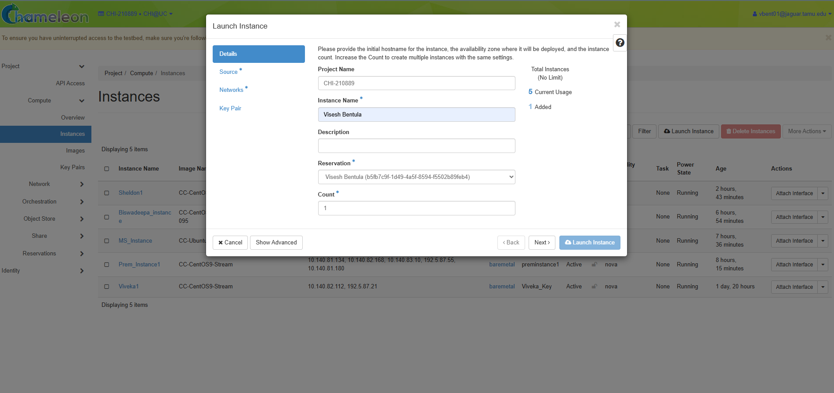
And now we can see the Launch Instance window and provide the details as per the manual

After details we also select the Source
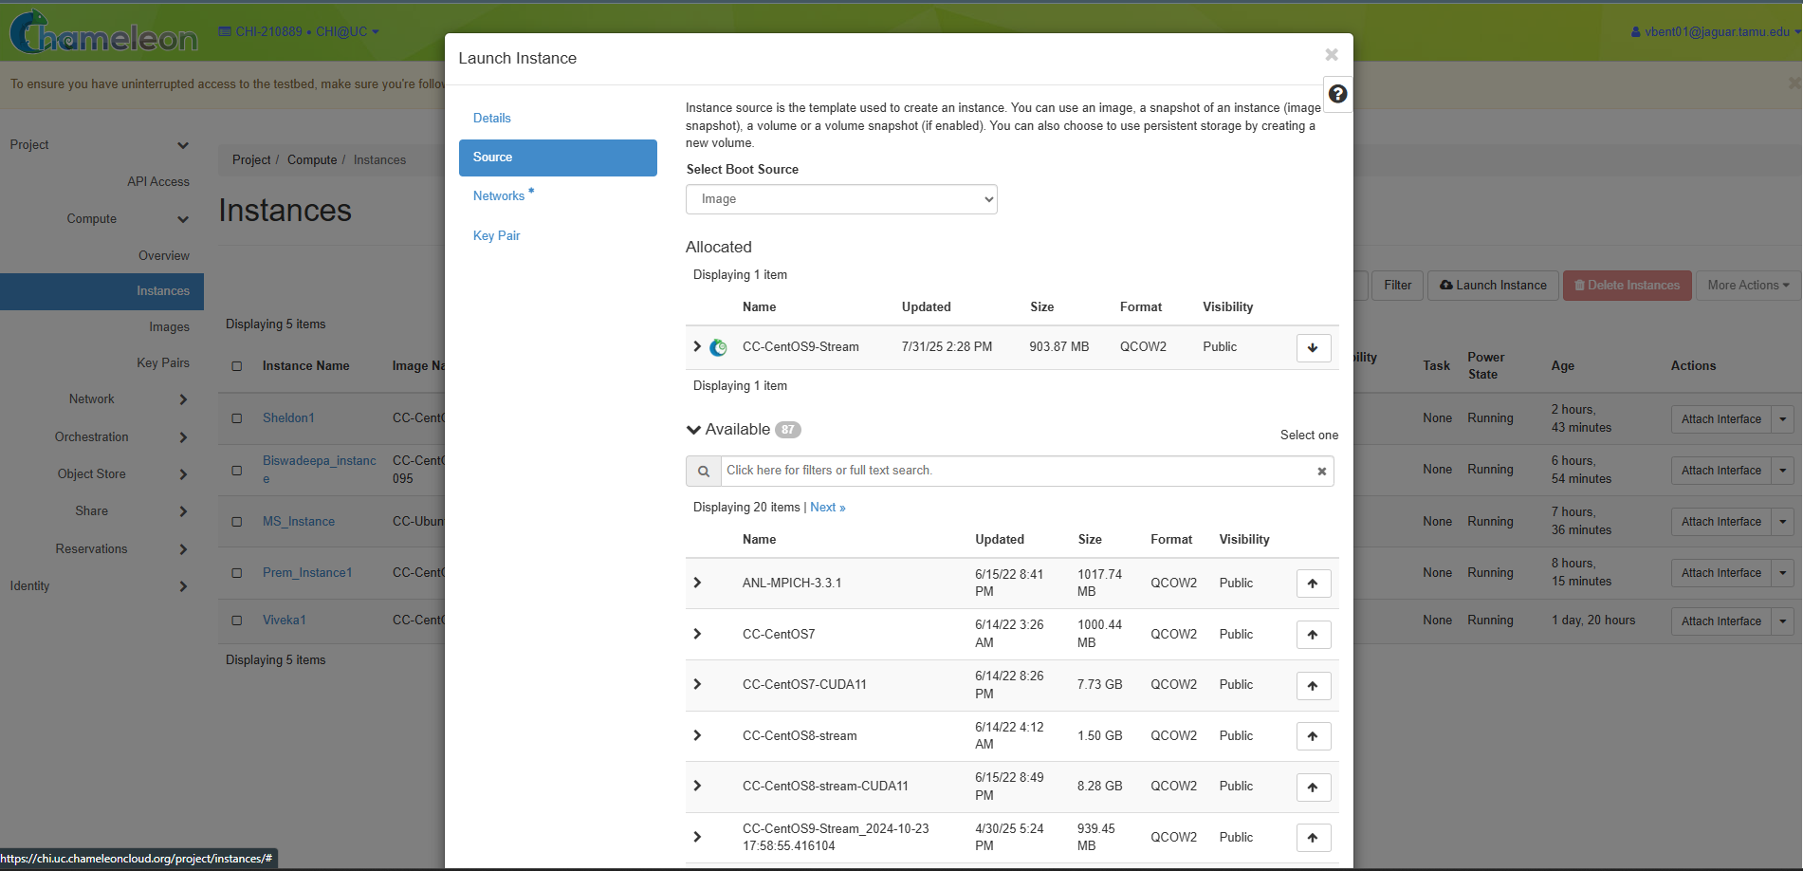
And the we have to create a Key Pair and once we create it, a .pem file will get downloaded..
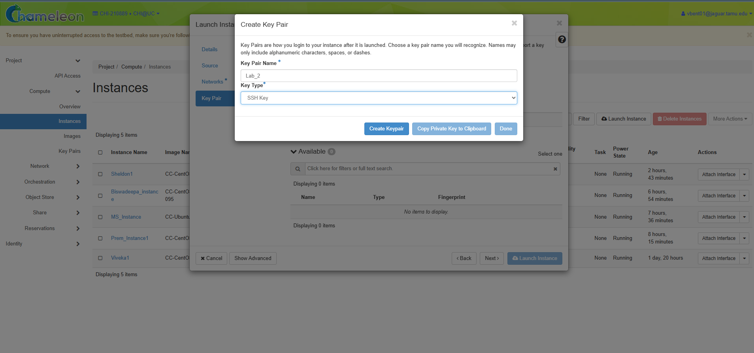

We have to select the network from the Networks Tab. I selected sharednet1…
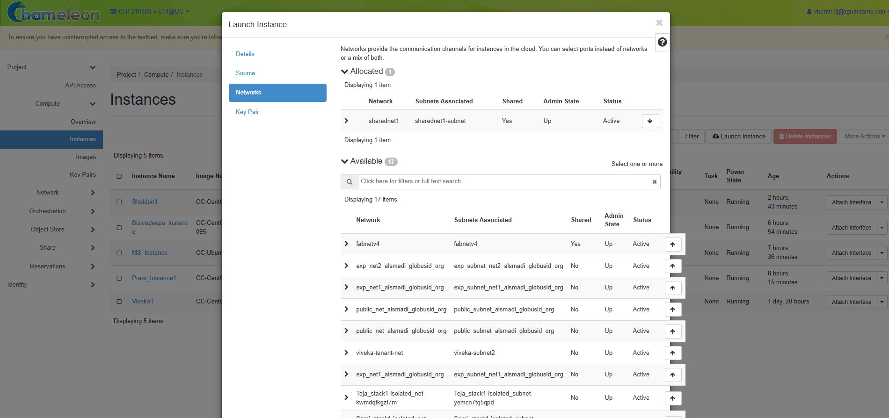
Then we have successfully created instance..
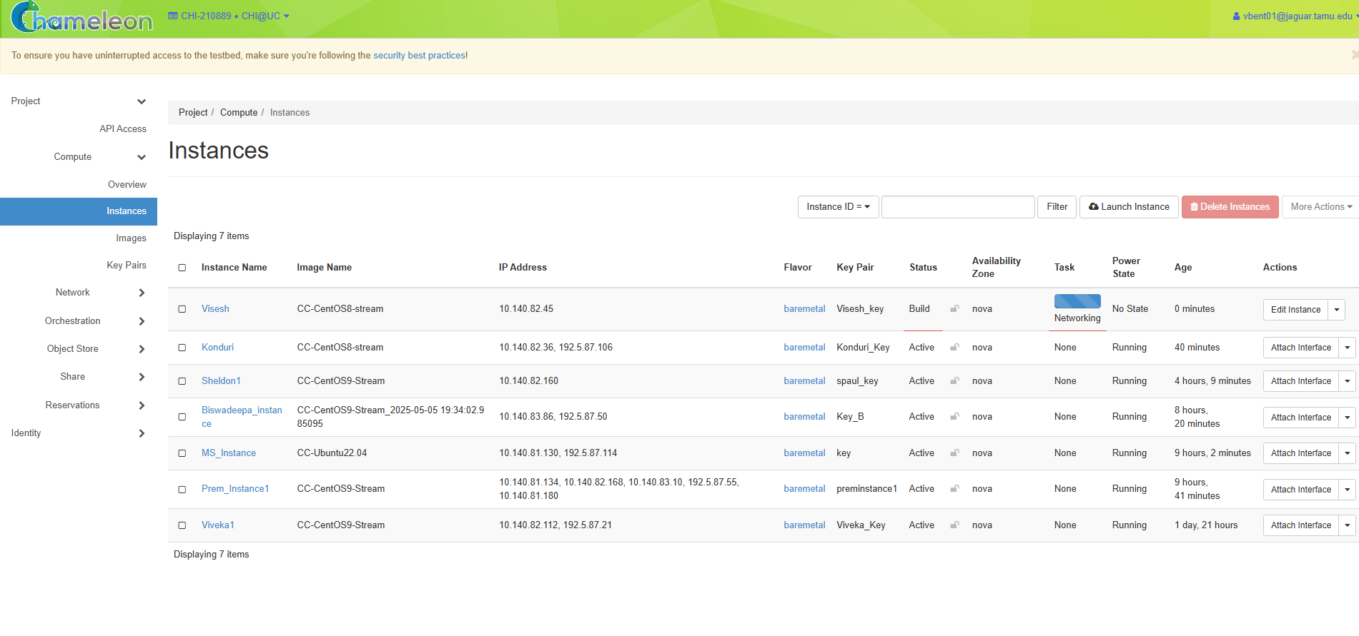

Then we have to create a Floating IP from the Floating IPs section from the Network -> Floating IPs..

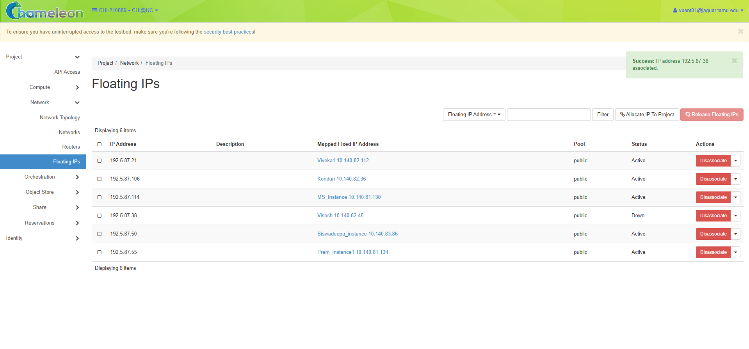
After that we will get an IP address and then we have to install bitvise SSH client from the internet.
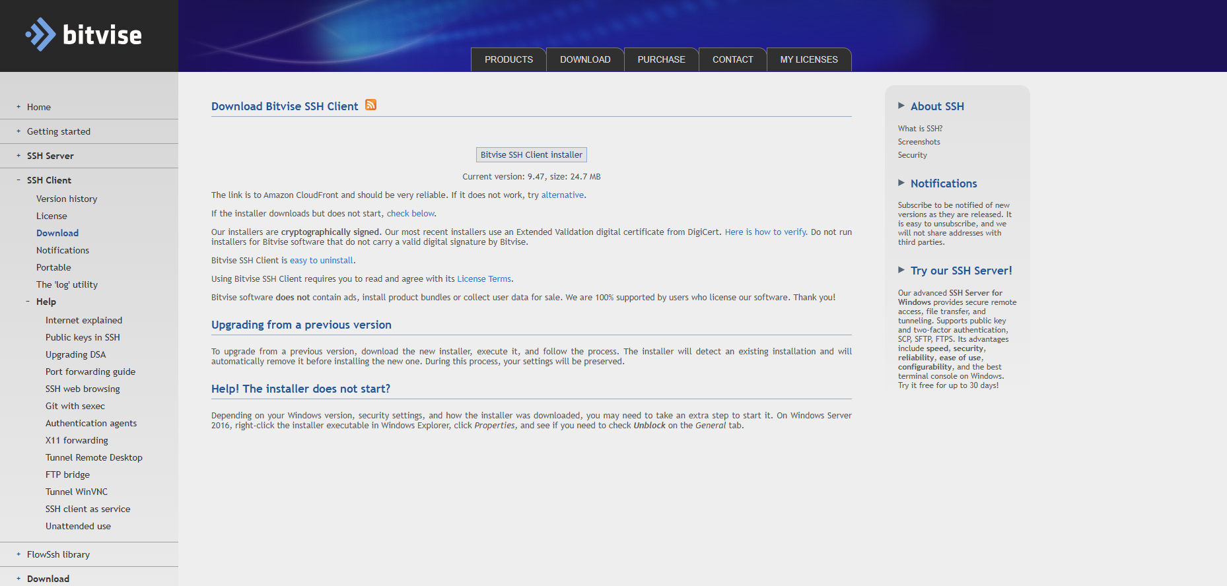

After installing, the downloaded .pem file is used here. So we import that in the Client key manager section.
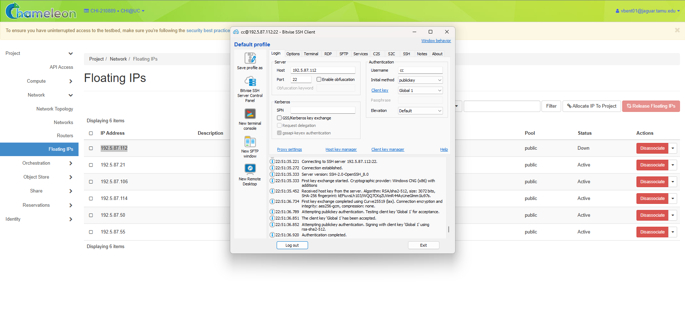
After importing it we Login and then click on New terminal Console and a console opens..

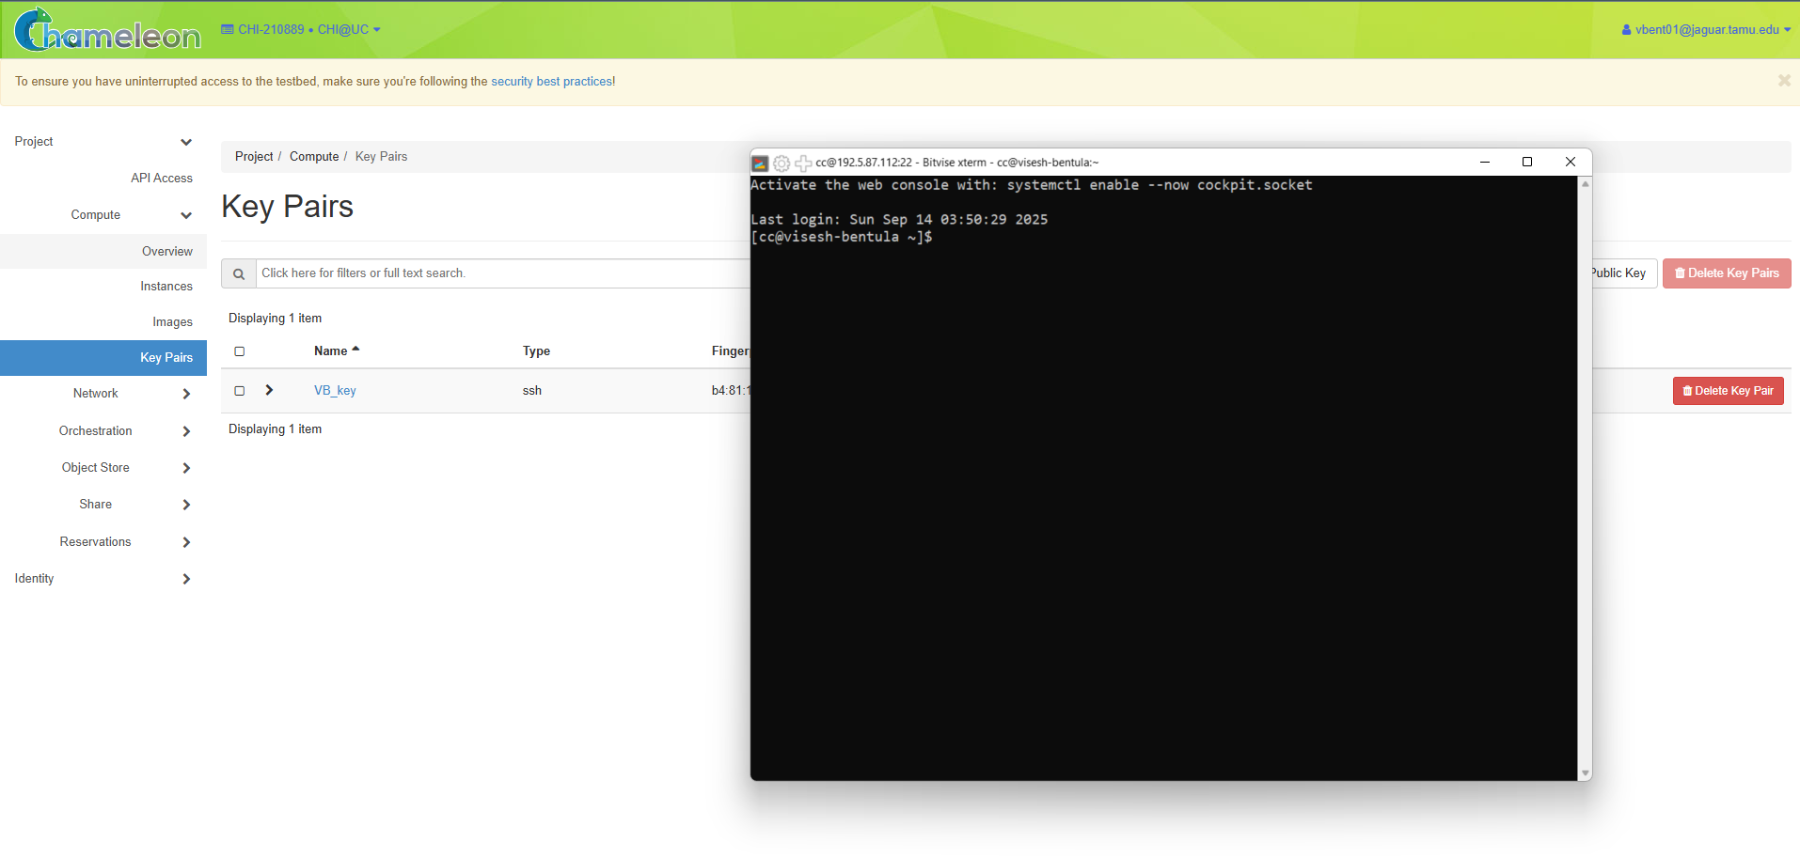

And we have to run the following commands as per the manual
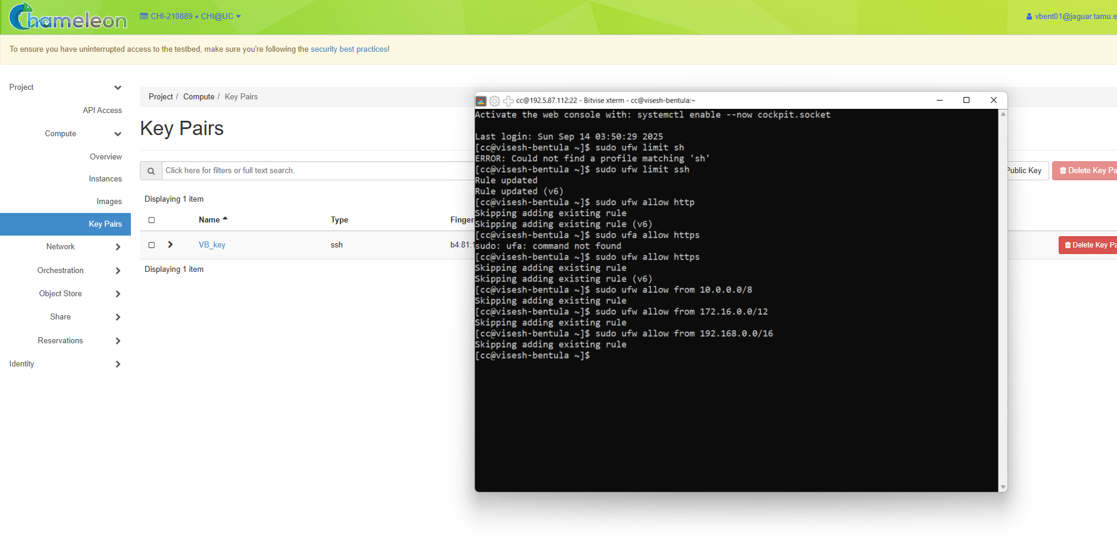
After that we open stacks from Orchestration -> Stacks..
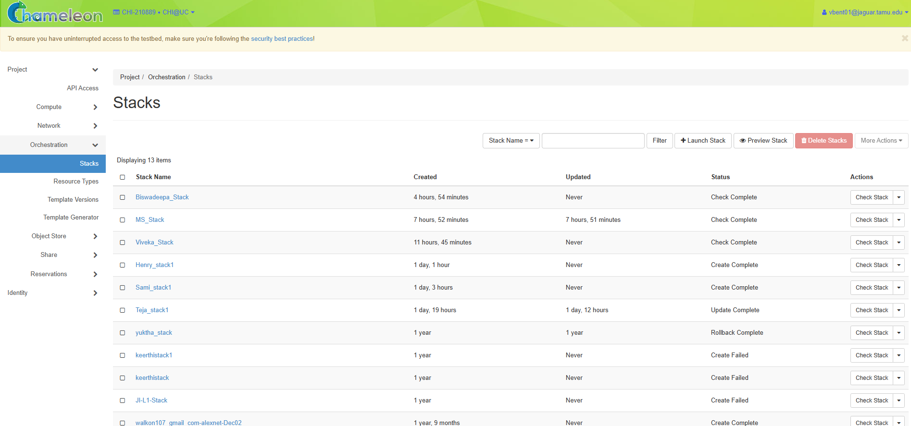

After opening it we click on create a stack and then select Template and give the template URL as per the Manual.
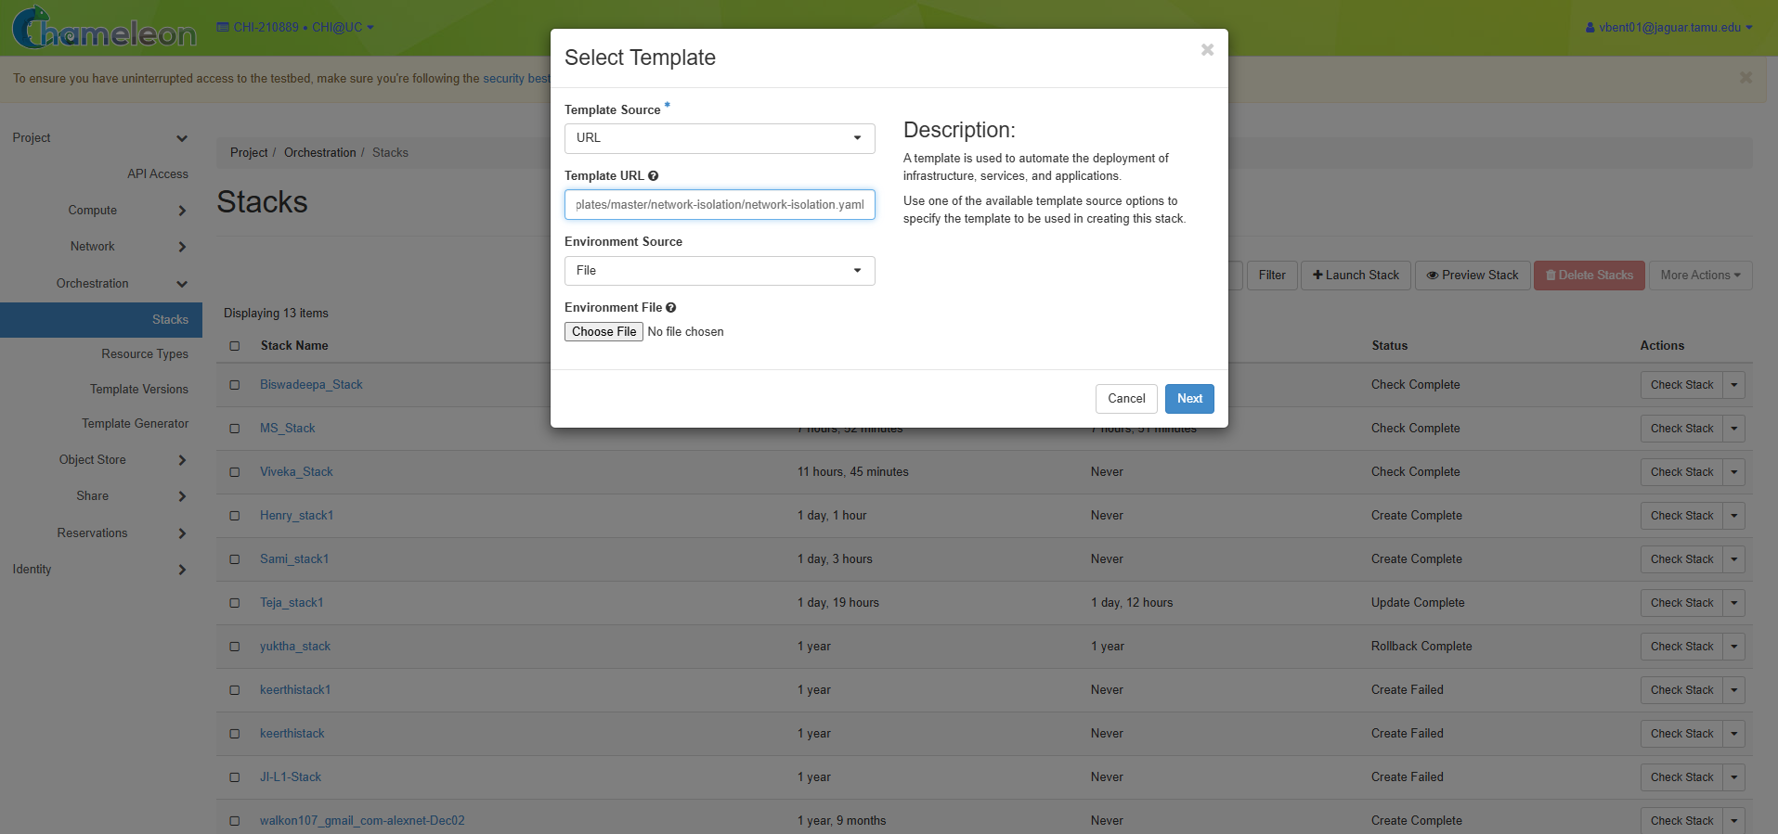

Then click next and then we launch it
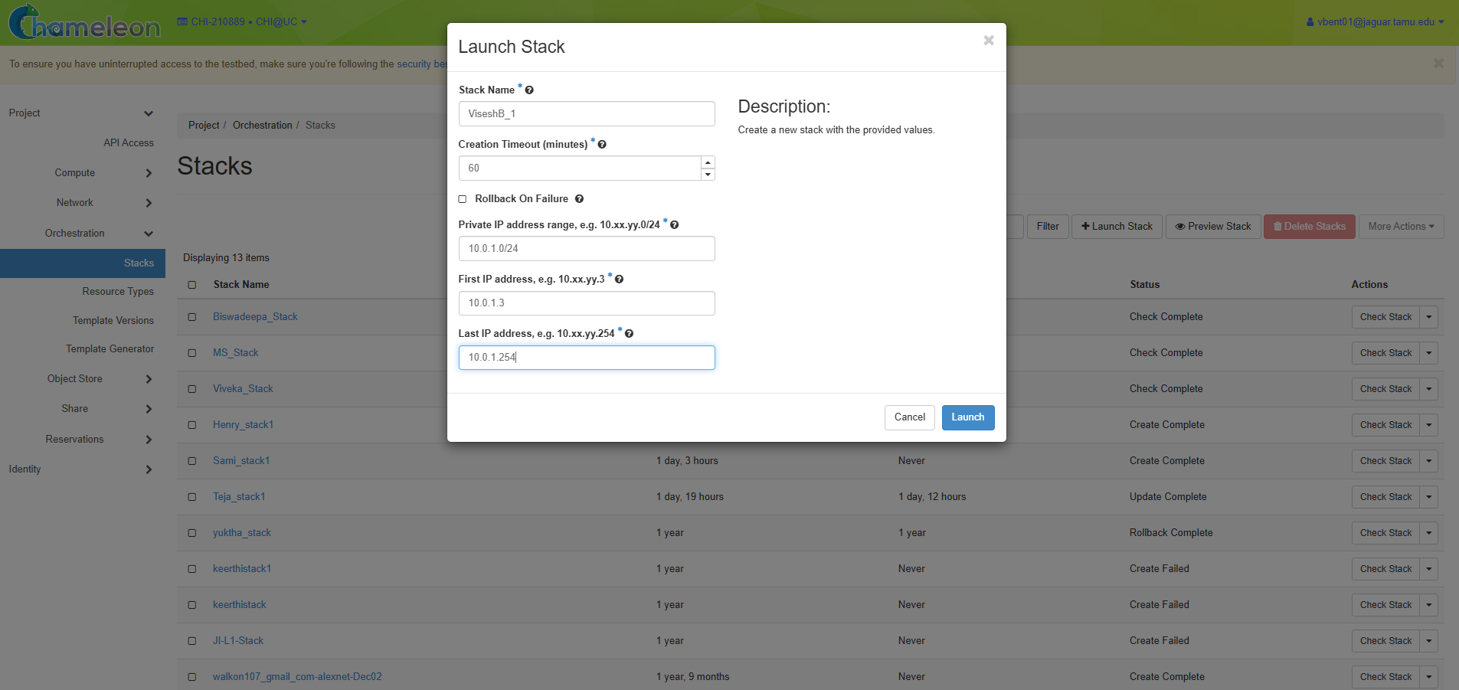

Now you can a Stack
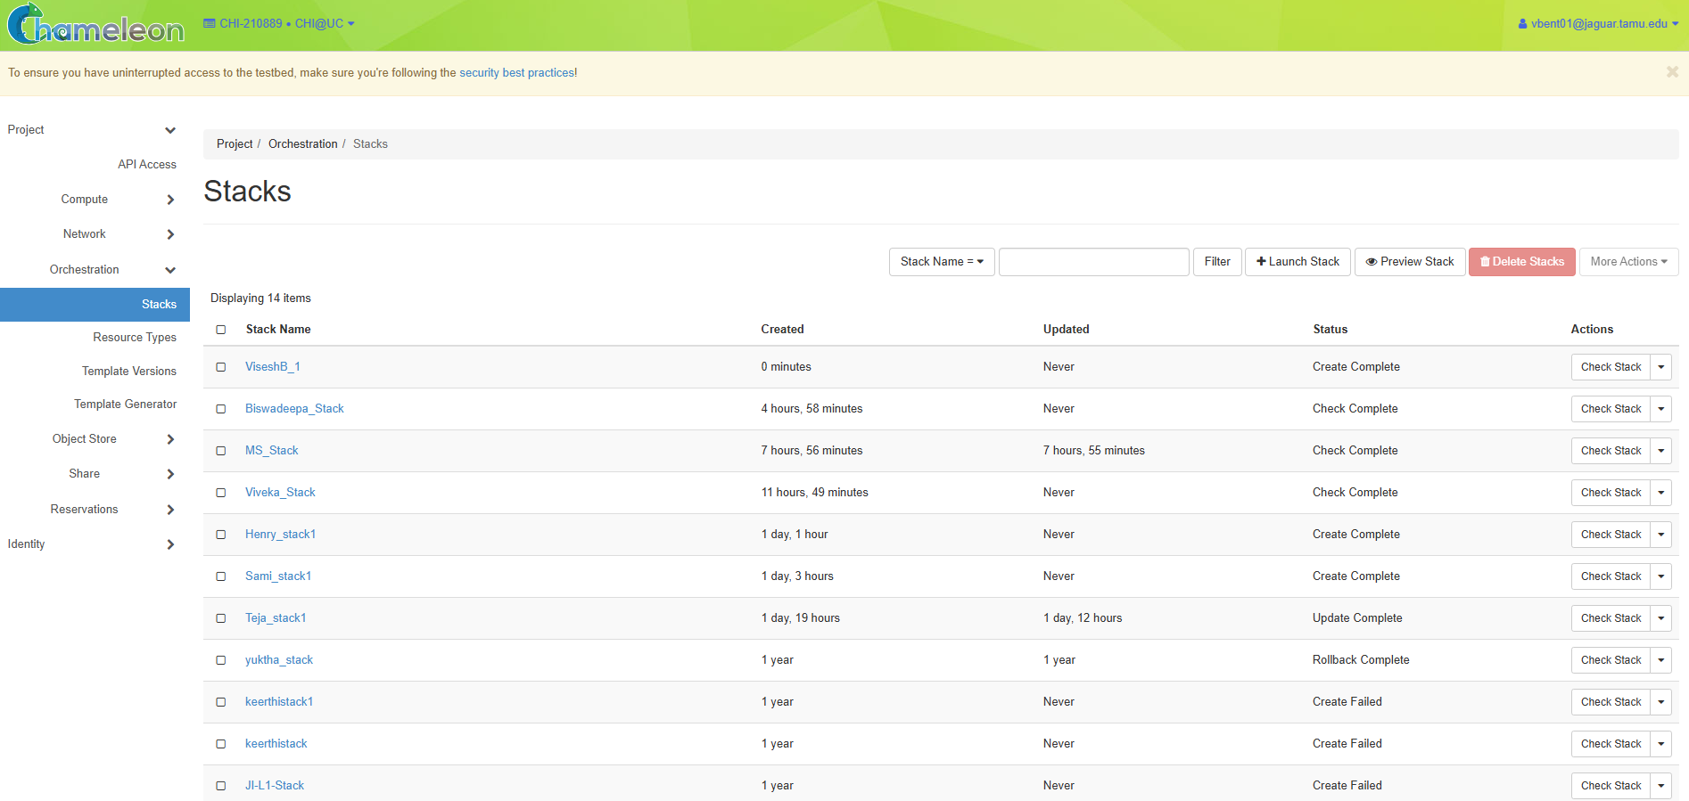
And select the stack you created and then you can see the details below and then click on Over view option..
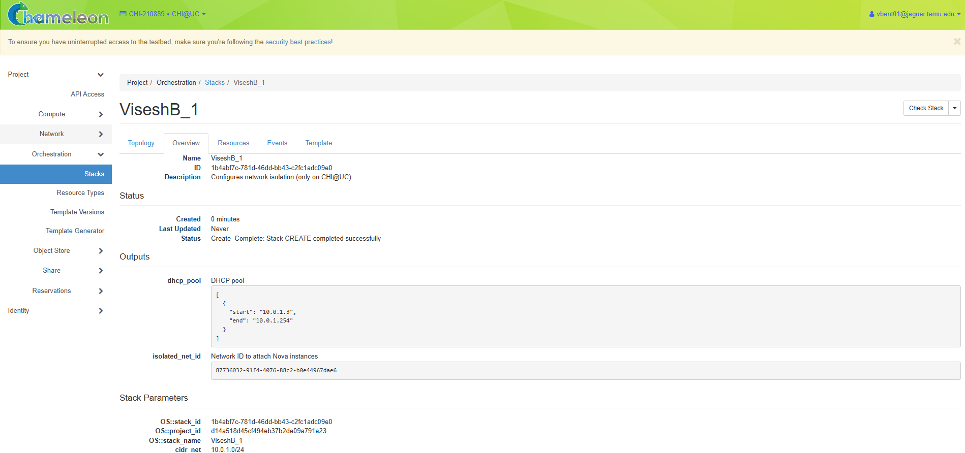

And click the Topology after that and you can see the below image..
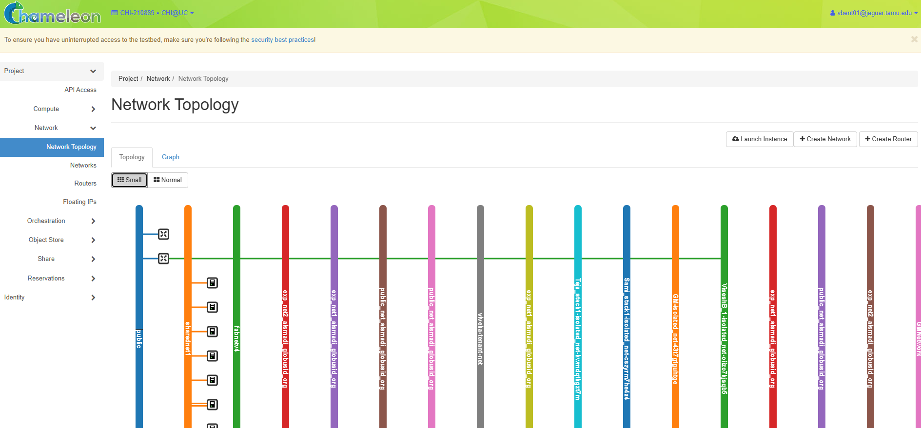

And Now we create a Network from the Networks window (Network -> Networks)
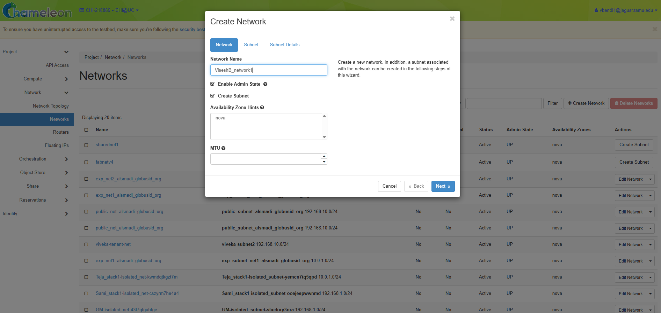
And fill the details as per the manual.

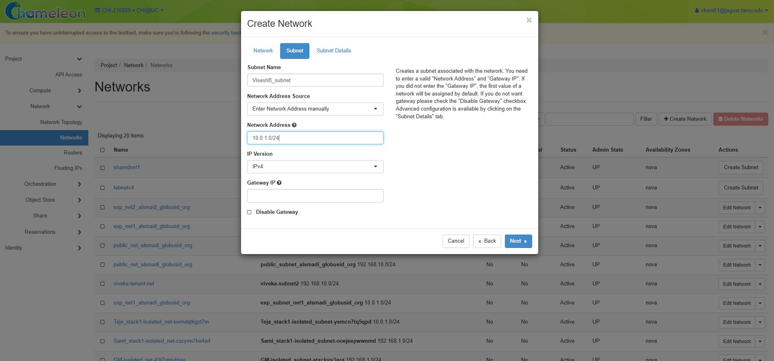
After that we click on launch and then we can see a Network..

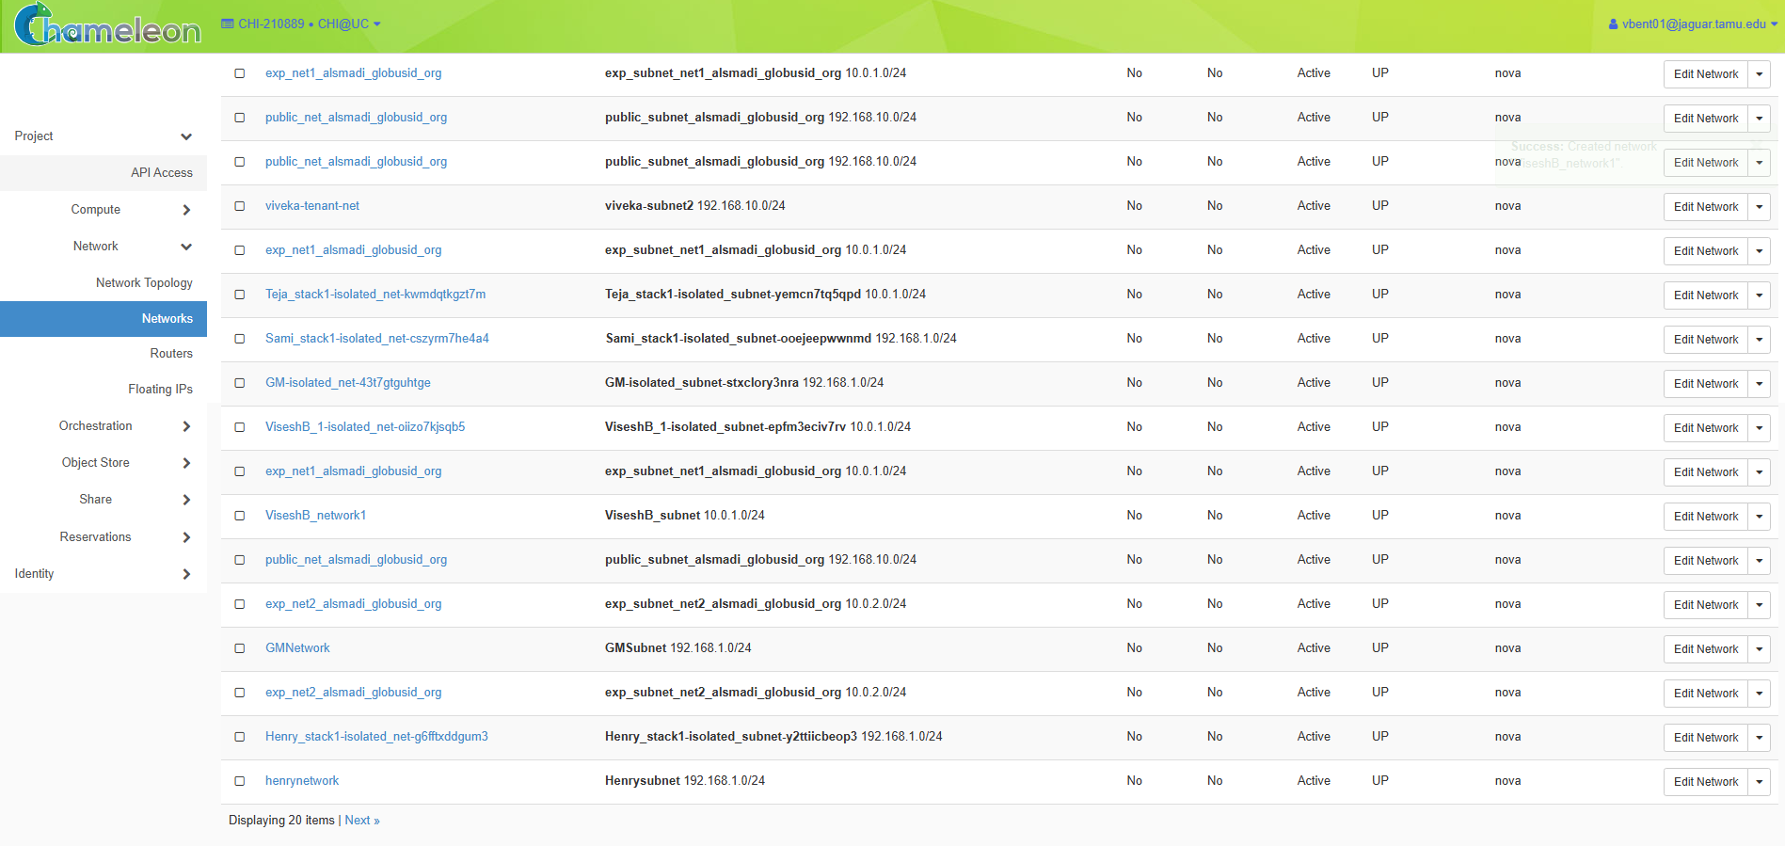

Next we must create a router. Go to the Network -> Routers
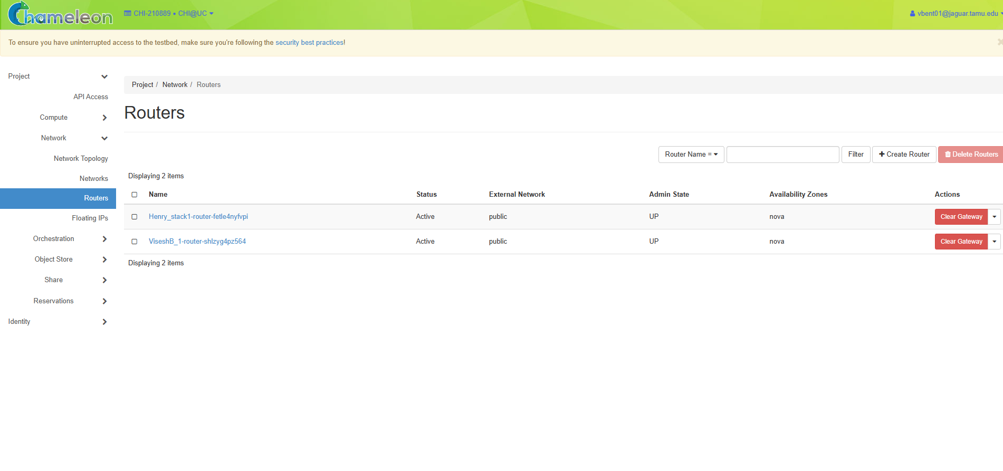
And then click on create router option and fill the details as per the manual..
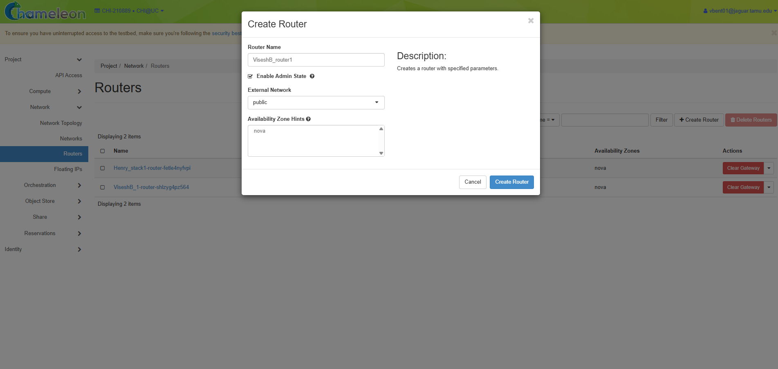

After that we can see the router being created..
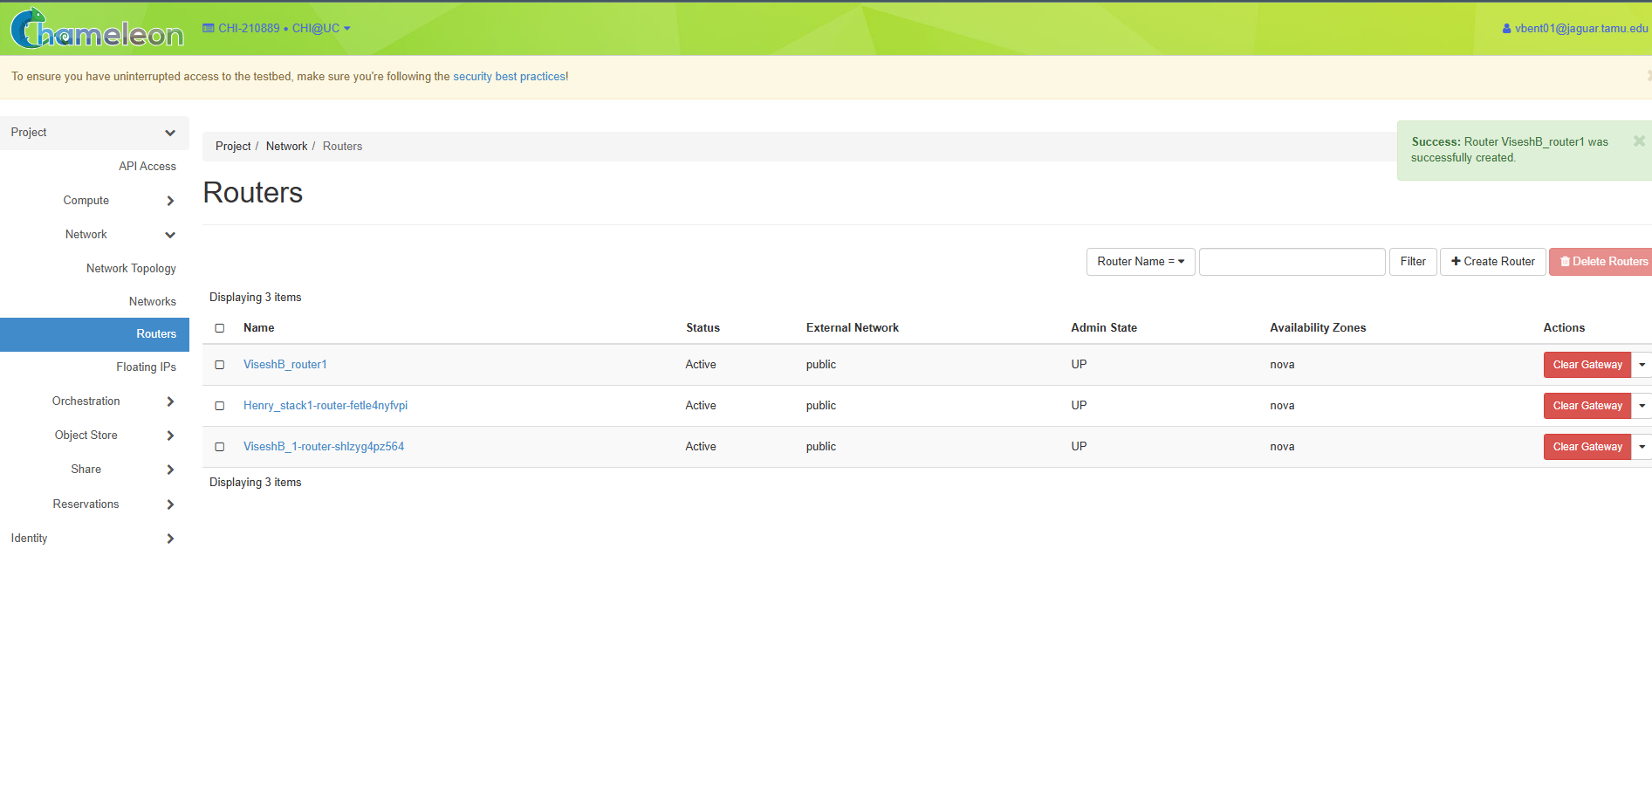
After that click on the router you created then you can see there is no inference.
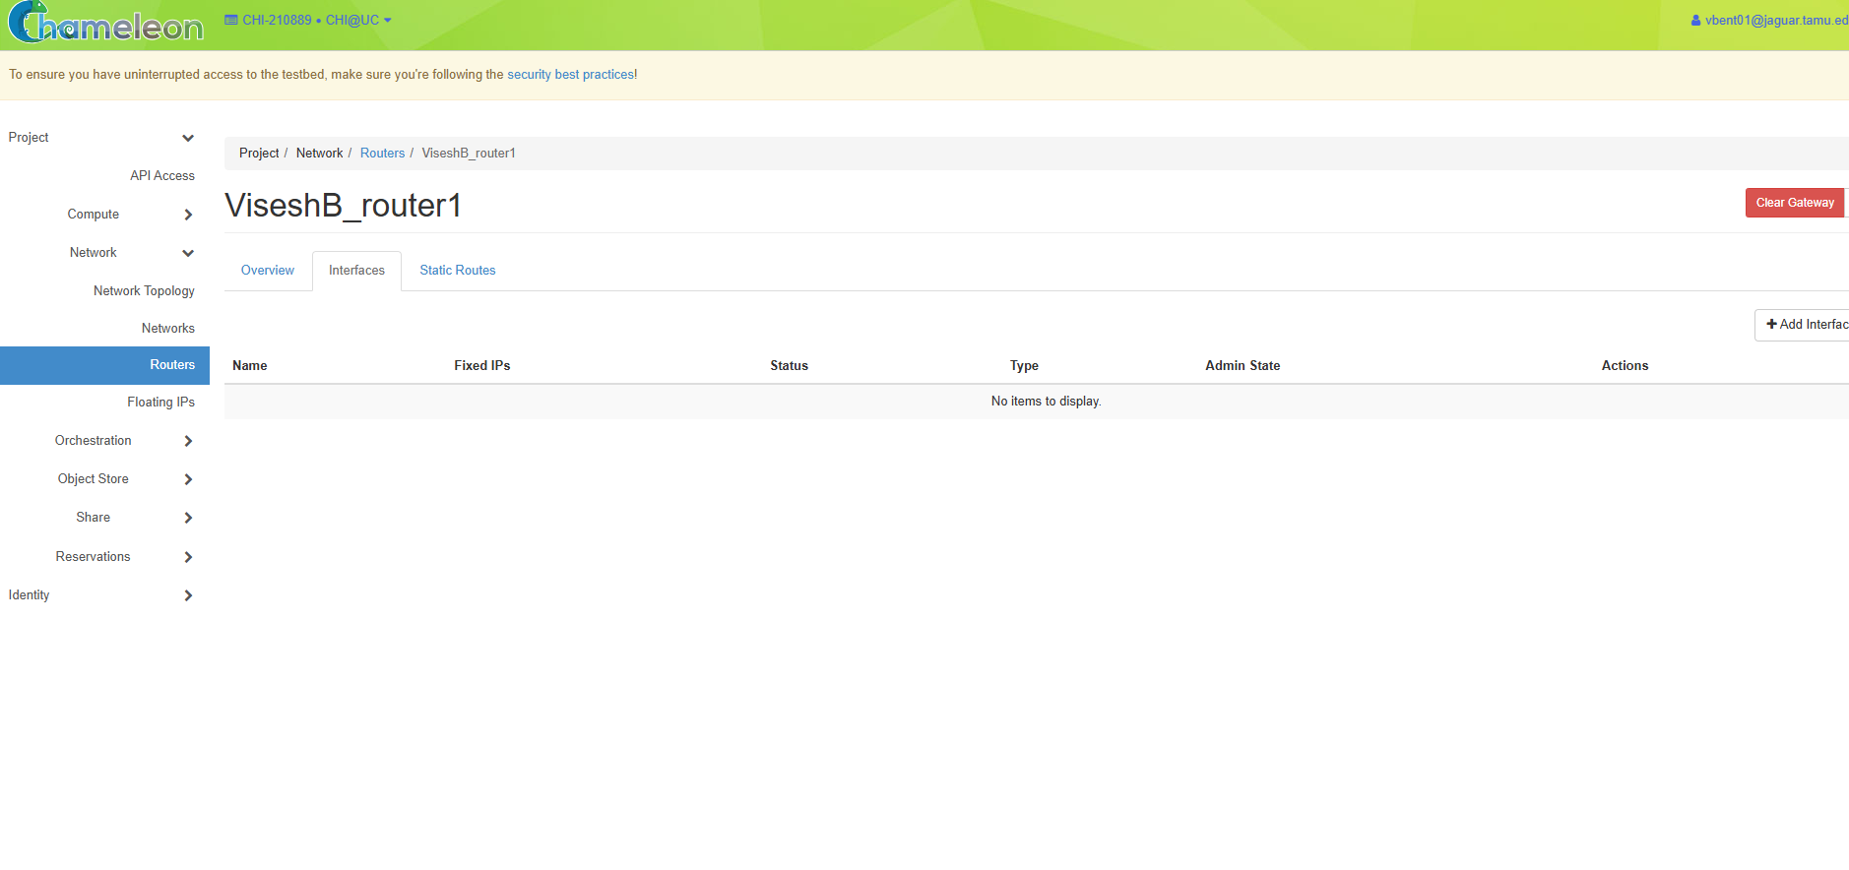
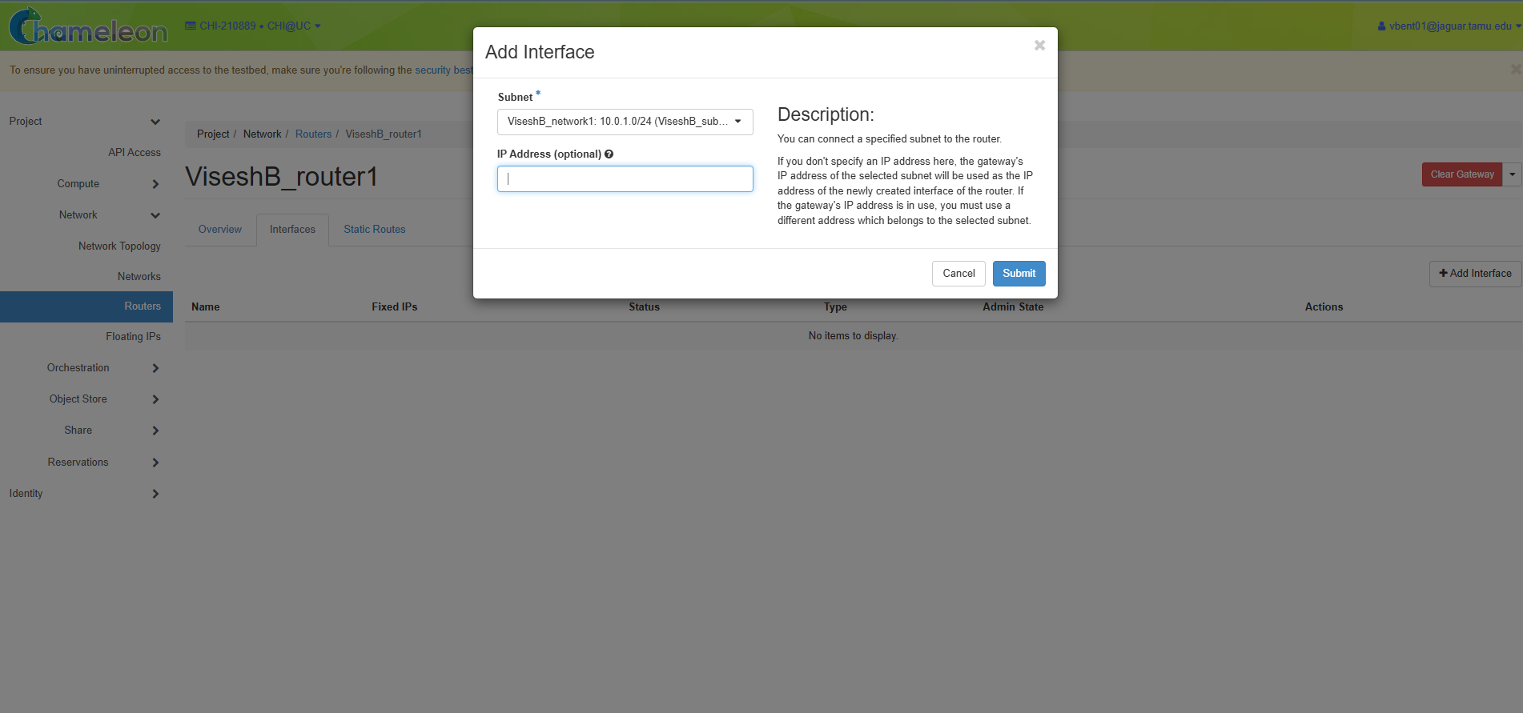
We create an inference by clicking on the create inference option. (As per the manual)
And we can see an inference..

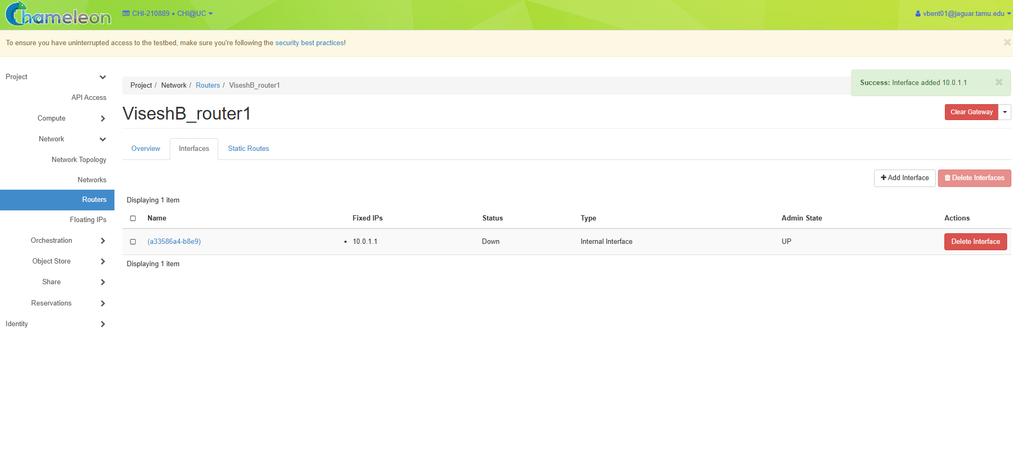

And from now the deleting part starts, we just delete everything we create.

Deleting router by clicking on delete
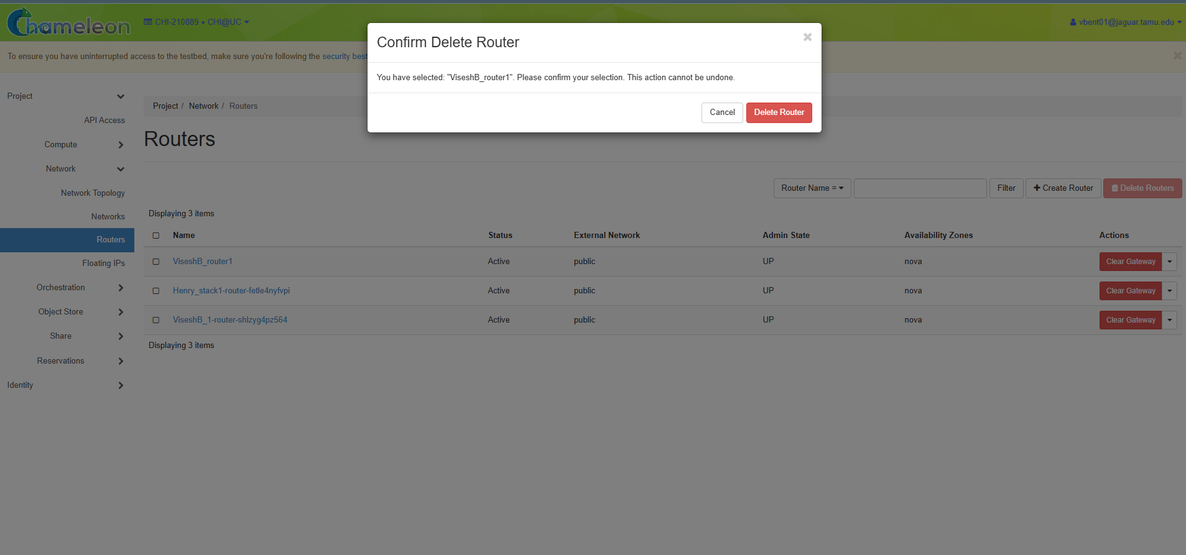
You can see router getting deleted successfully

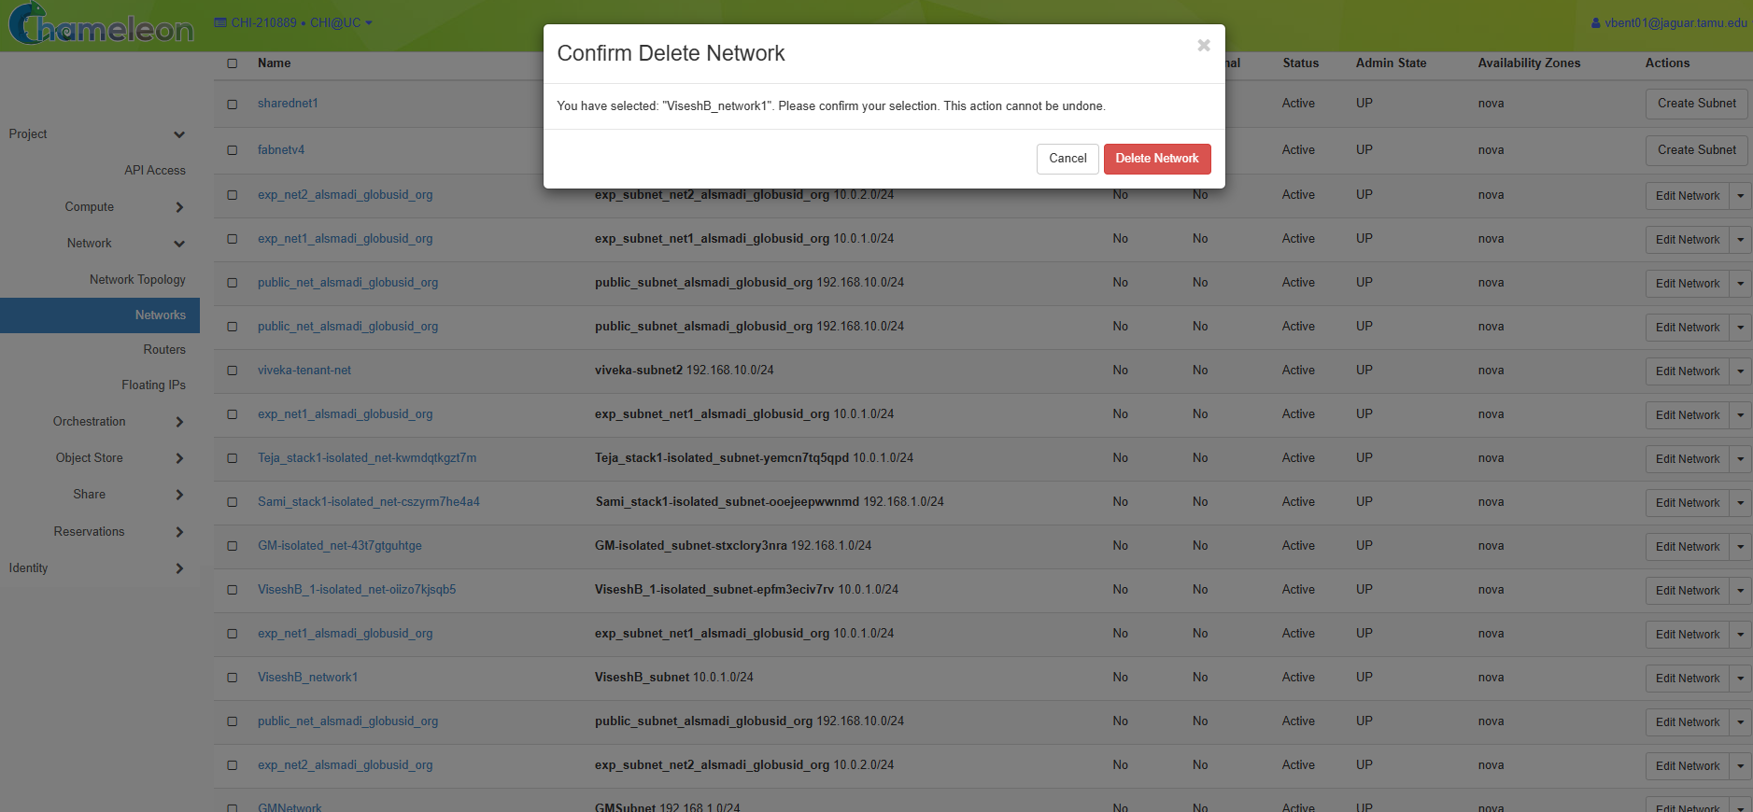

Now we do the steps using console
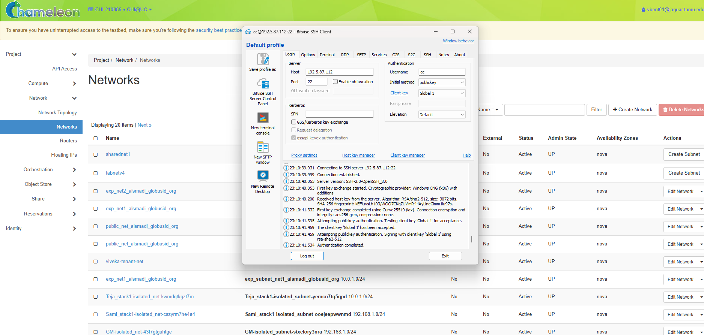
We open bitvise and login using the .pem file. And the type in the command :
Openstack network create Visesh_Network1, then u can see the network field

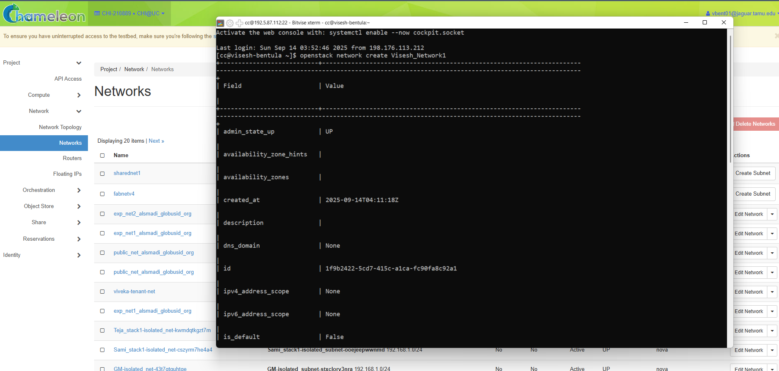

WE can see a network getting created.
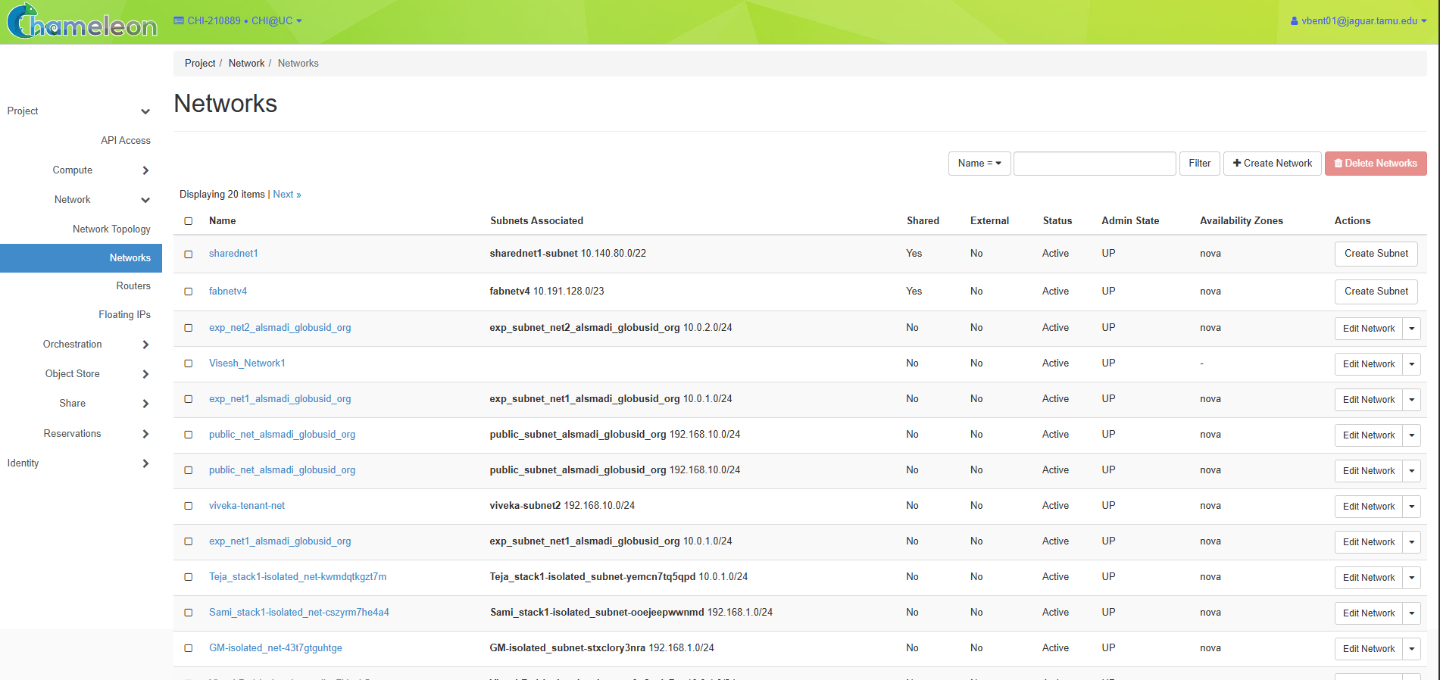
Now we create a subnet in the same network by typing the command:
Openstack subnet create Visesh_Subnet1 –network Visesh_Network1 –subnet-range 10.0.1.0/24

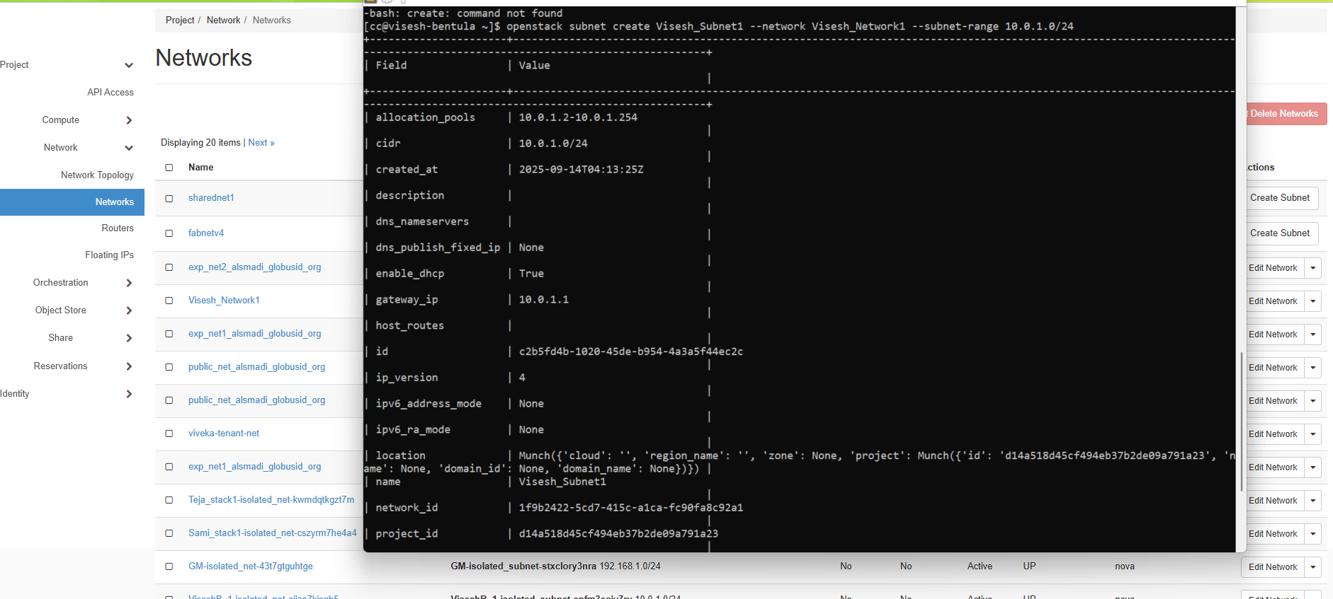

And now we can see the subnet details in the network section we created using console
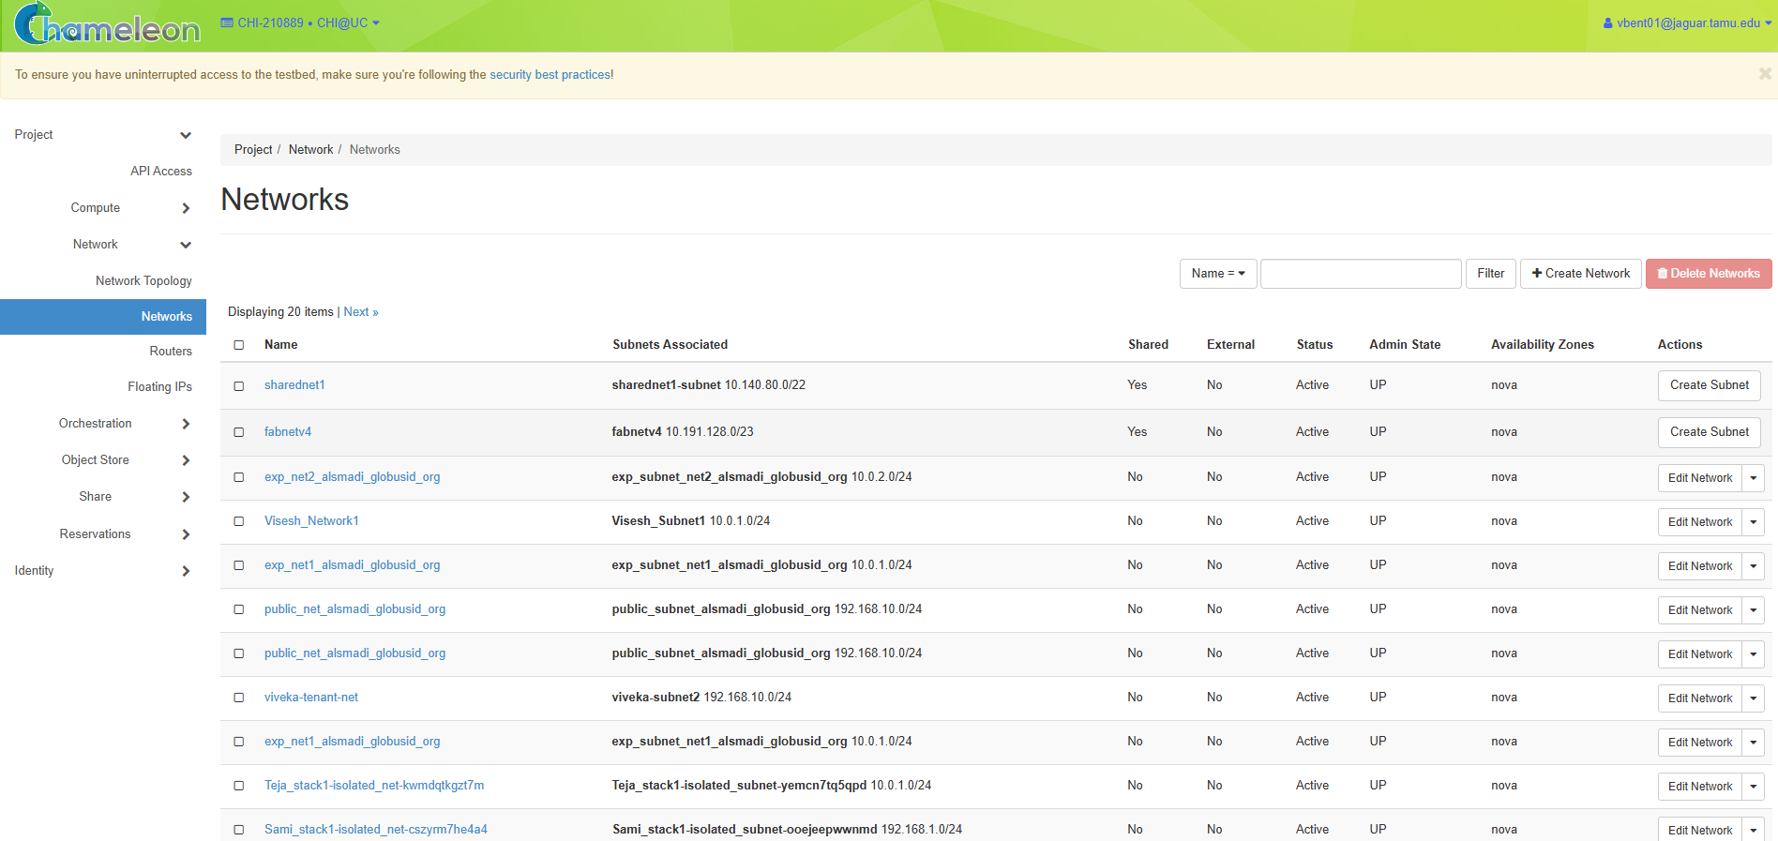
After that we create a router in the same fashion
Command used : openstack router create Visesh_router1

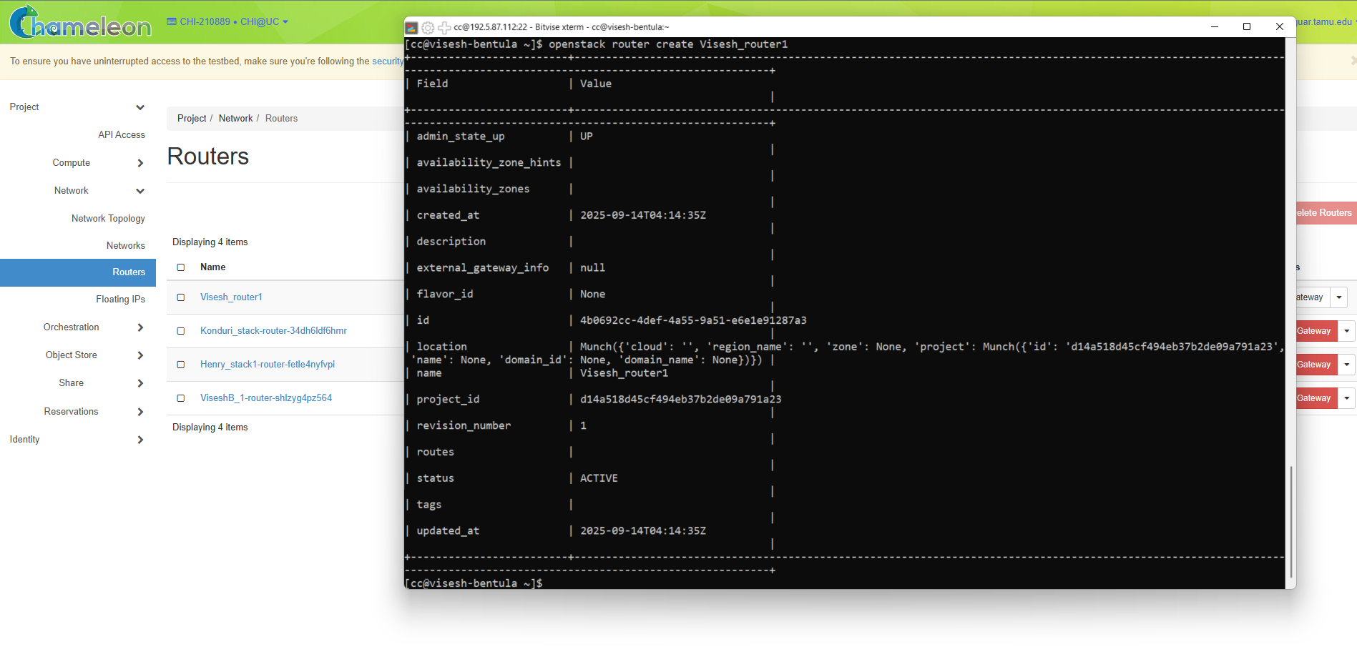

And we can see the router getting created
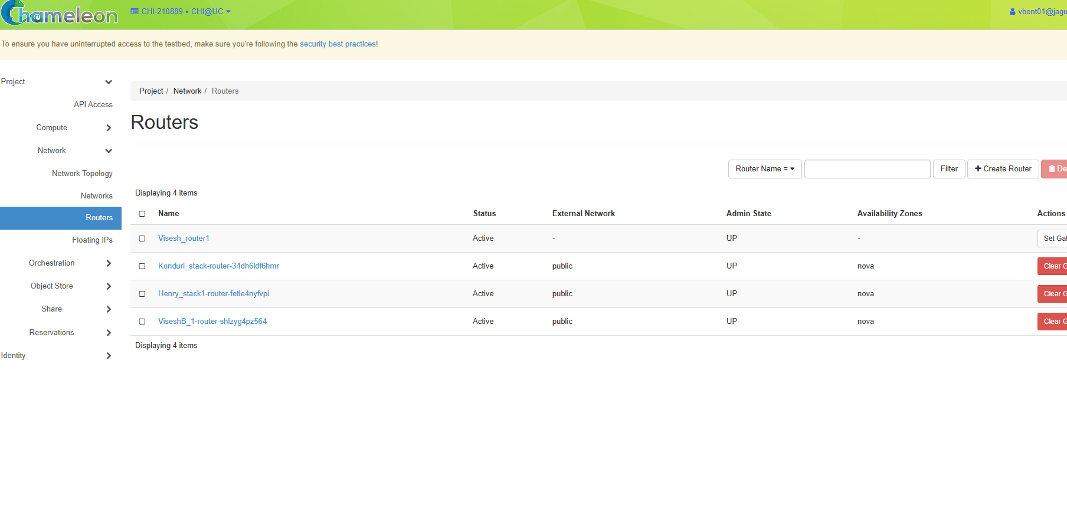And now we add the inference using the command below
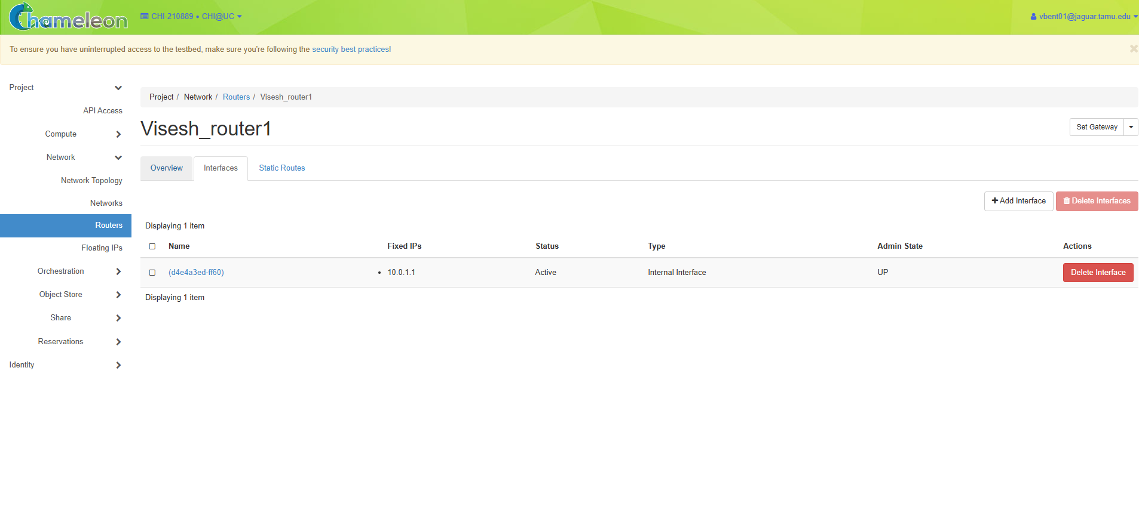
And we set external gateway by the following command below:

We can see the gateway getting created

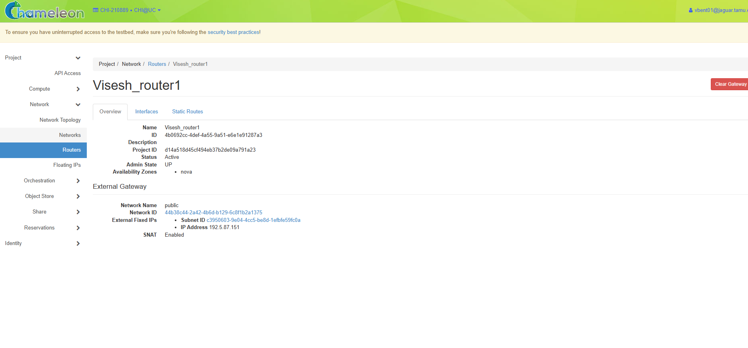
And then unset it using the following command below

And now we can see the gateway getting unset and the section being empty
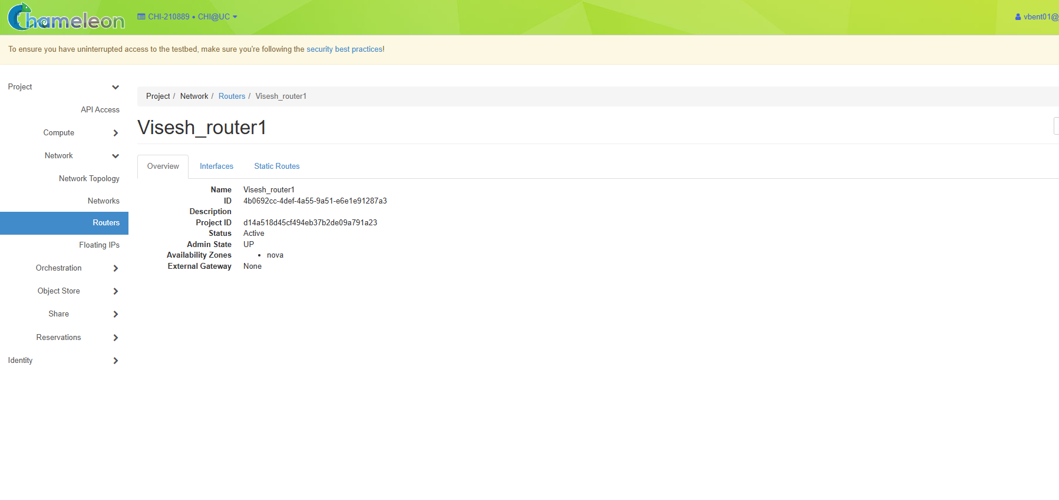
And now we remove the inference we created before by the following command below
And we can see the inference being removed
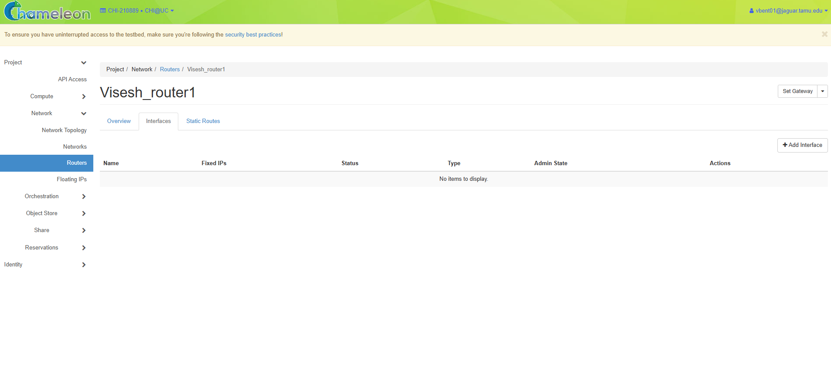
And then we remove the Router we created
And we can see there is no router
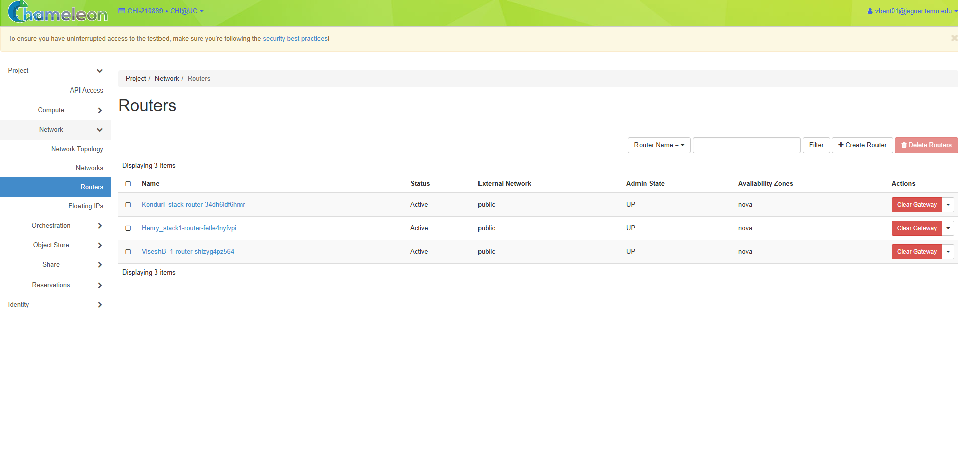
And now we delete the network we created using the console
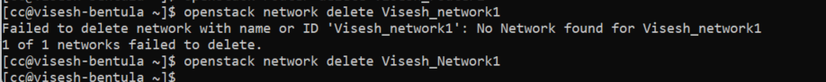
And now we can see there is no network named: Visesh_Network1
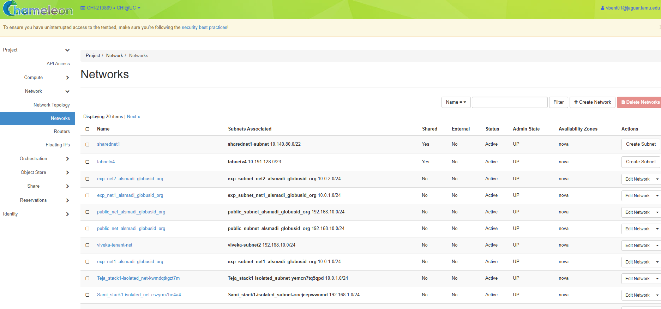

Monitoring tools:
We use few monitoring tools suggested from the youtube video:
We tried checking if openstack-client was there and if yes it is updated!!
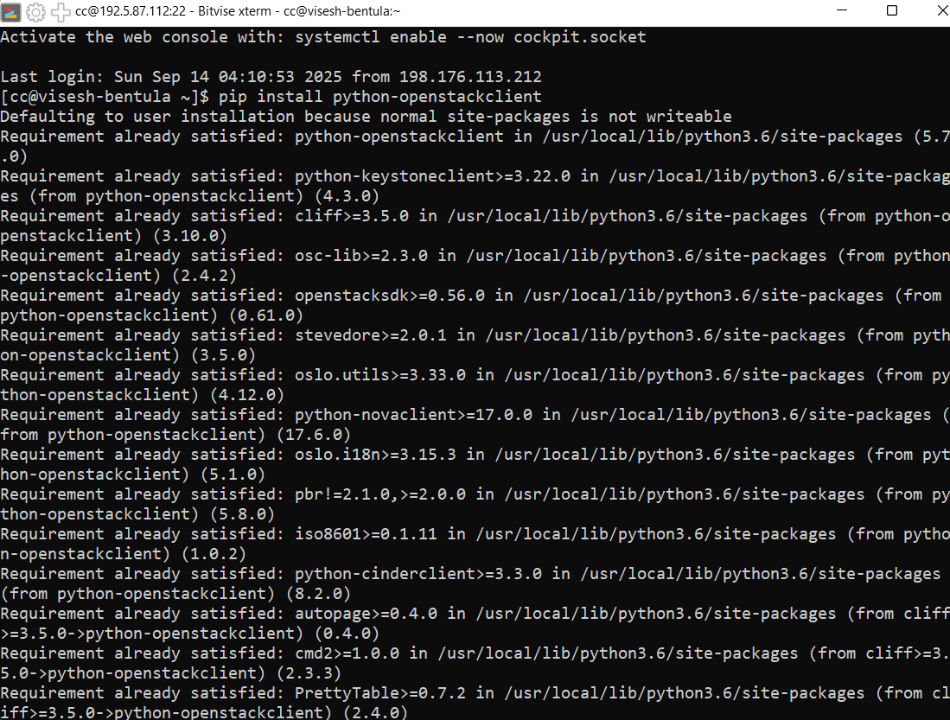
As per the video we start by downloading the Openstack RC file from the right side top corner dropdown options near the email ID
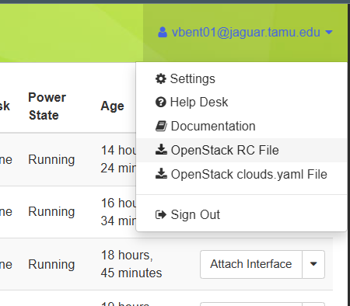

We can there is a script file downloaded..

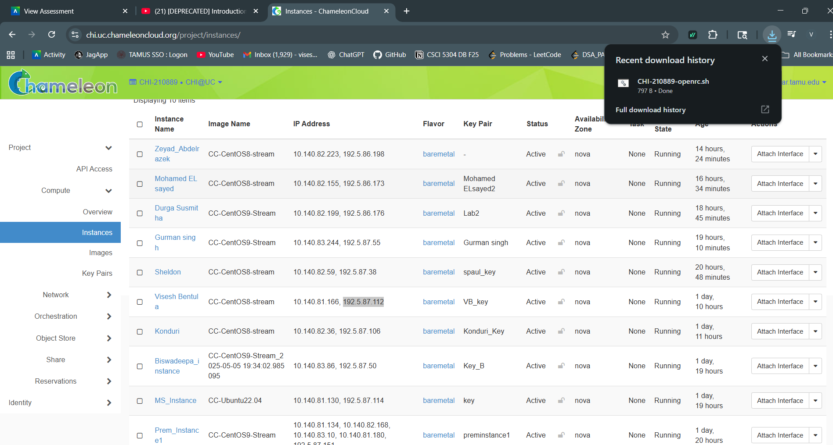
And we transfer it the bitvise SSH client from the option New SFTP window which looks like below image
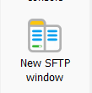

Here you can see the file getting transfer to the remote server
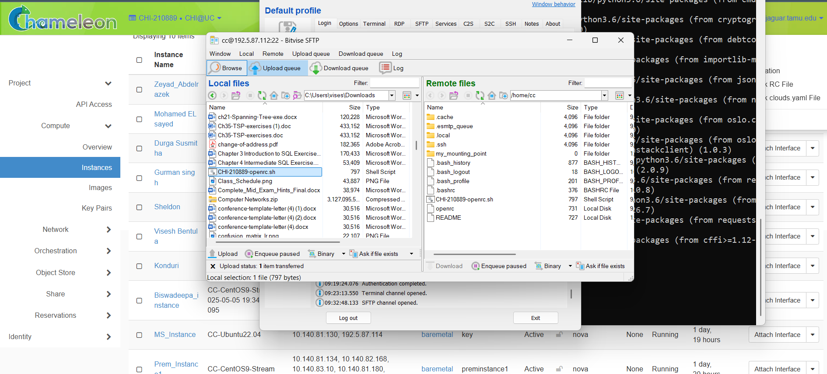
And then try to open it and see few details
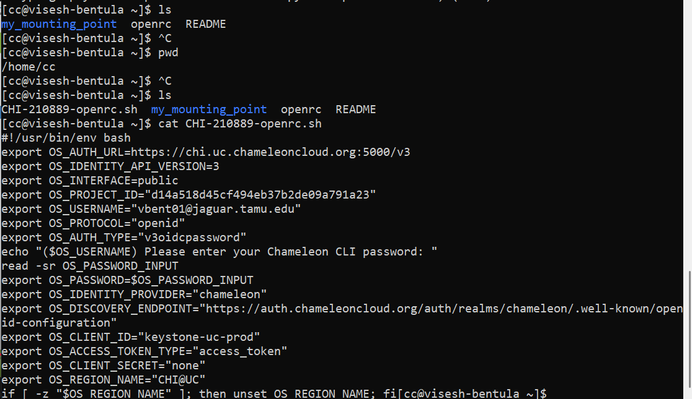
And copy the script and paste in a new file named something.sh as per the video

Now you can see I tired opening the file and if the code got pasted or not..
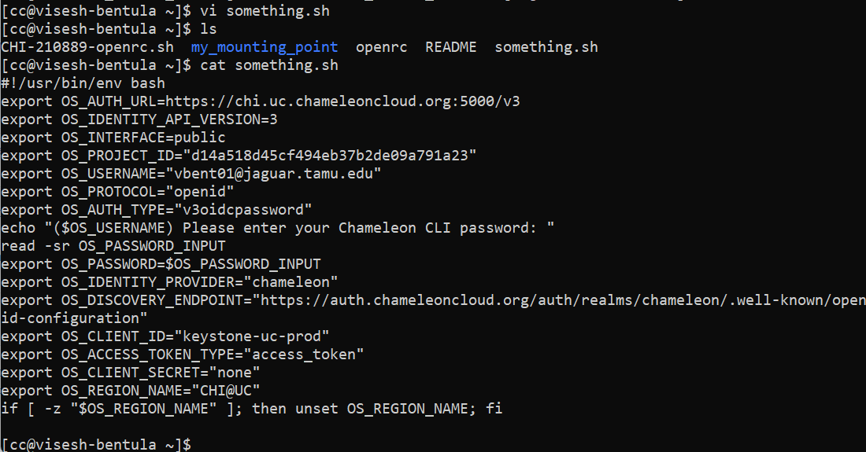
And now we check the server list as per the video says..
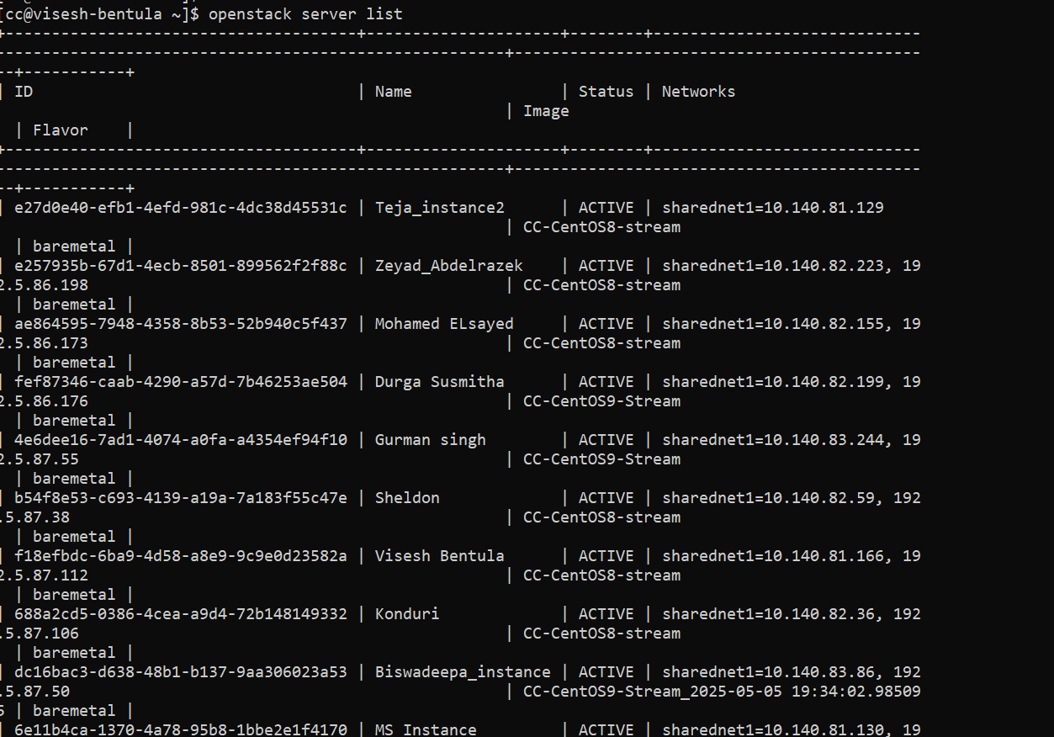

And we use the command as per the video… And we can see the metadata

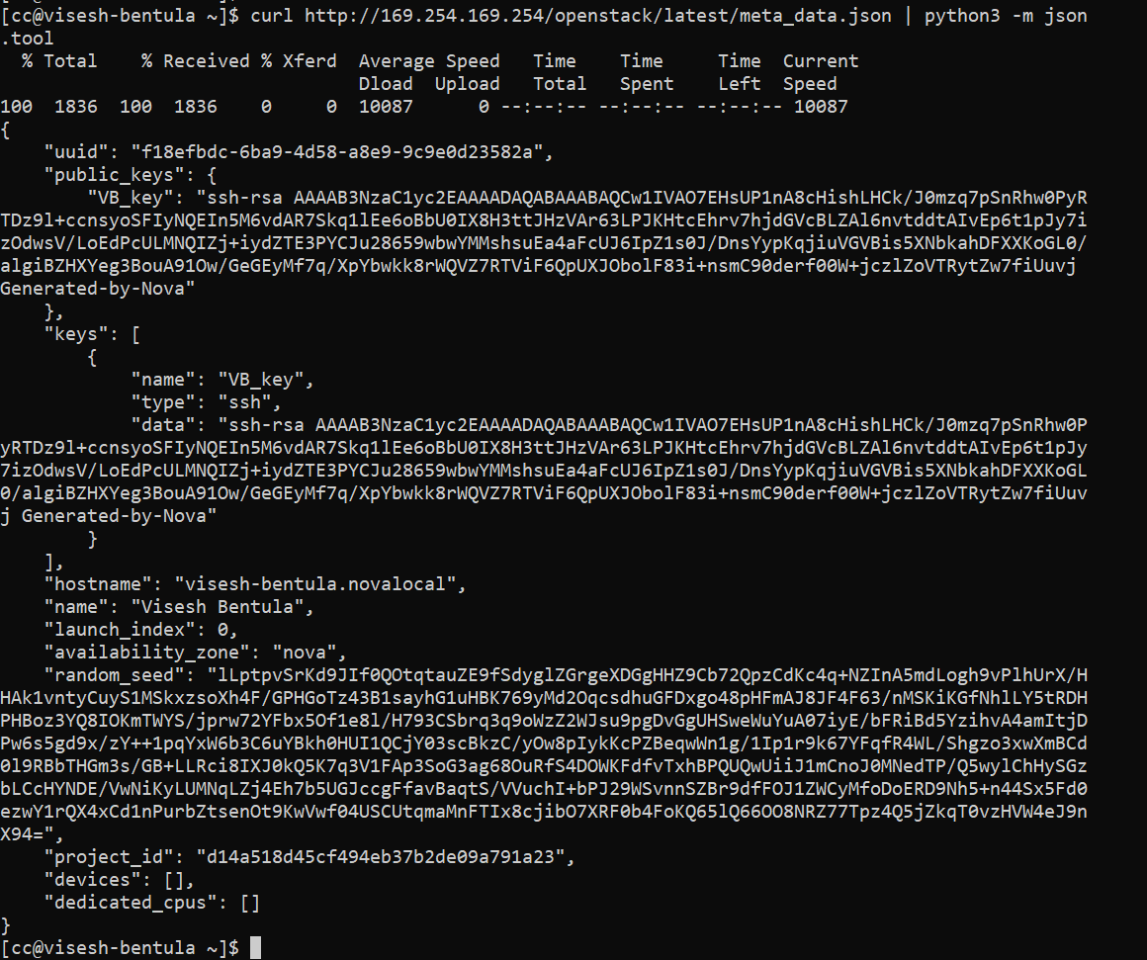

But the list metrics from the video:
From the internet:
The reason the command openstack metric resource show doesn’t work on Chameleon is because it relies on the Telemetry/Gnocchi service, which used to be part of OpenStack for exposing instance metrics like CPU and memory usage. However, the OpenStack community officially retired Gnocchi and the Telemetry project several years ago since it was complex, had scaling issues, and very few cloud operators wanted to maintain it. As a result, modern OpenStack clouds — including Chameleon — no longer deploy it, so the metric commands don’t exist in the current CLI. That’s why even if you find the instance UUID, you can’t query metrics with resource show anymore.
I tried other commands listed in the internet
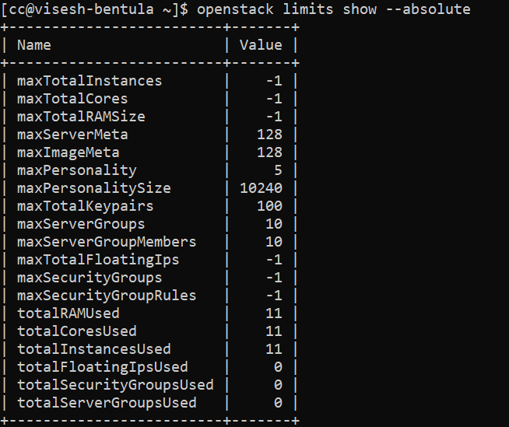

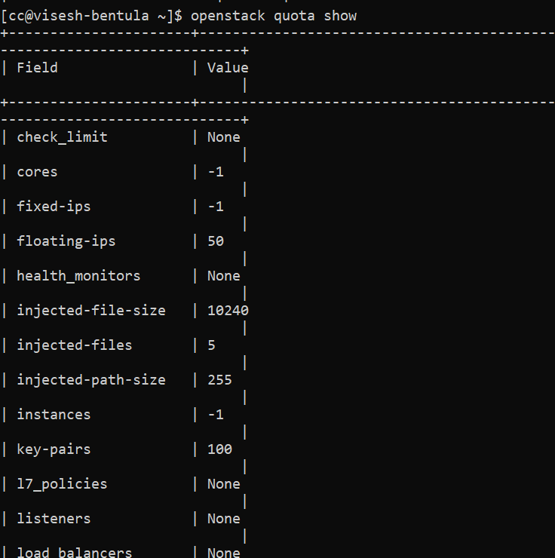
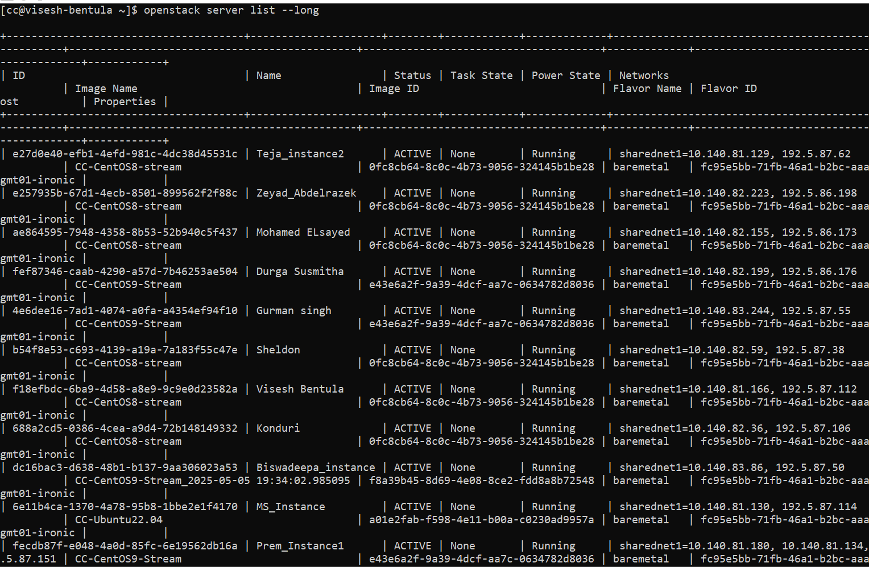
And the htop was not working as well as the video is outdated. So, I tried the traditional top command where we can see the details..

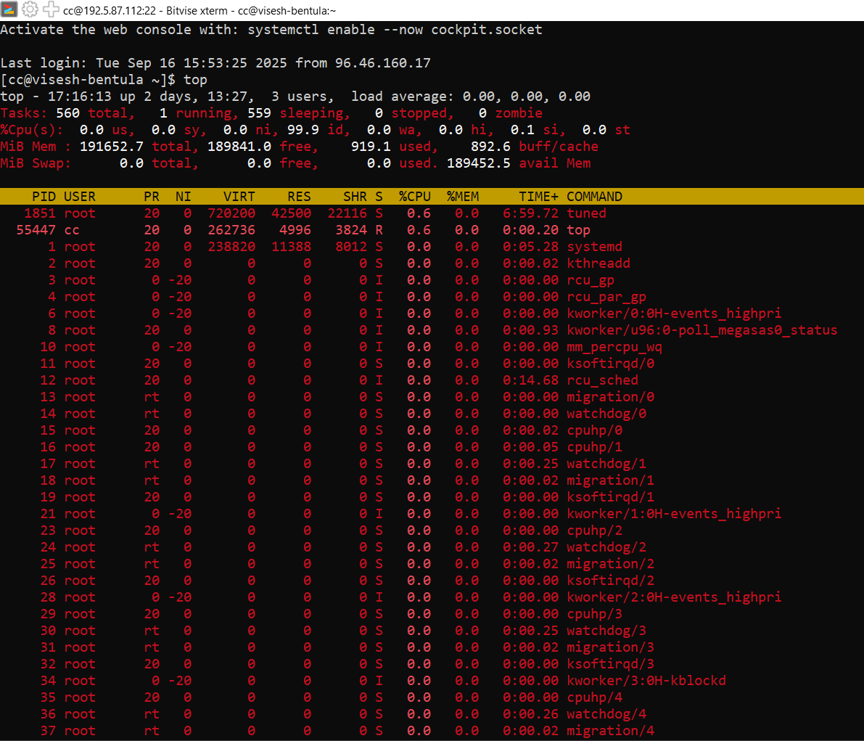

Summary:
In this lab, I worked with Chameleon Cloud to practice creating, managing, and deleting resources like leases, instances, floating IPs, networks, subnets, and routers both through the dashboard and the console. I successfully followed the steps from the manual to provision and later removed these resources. I also experimented with monitoring tools, transferring the RC file via Bitvise SSH client, and running commands from the console.
However, I faced a few challenges. Some parts of the lab didn’t go as expected because the YouTube tutorial I was following was outdated. For example, the video referenced the Telemetry/Gnocchi service for monitoring, but this service has been deprecated in modern OpenStack versions, so the commands no longer worked. Additionally, the tool htop shown in the video could not be used in the latest setup, so I relied on the traditional top command instead.
Another challenge was that I was working with the latest version of Bitvise SSH client, which has some interface differences compared to what was shown in the older tutorial video. This required me to adapt and troubleshoot as I went along.
FeedBack:
Overall, the lab was a good learning experience in both the dashboard and CLI workflows of OpenStack on Chameleon. I gained handson practice in setting up networks and routrs, working with floating IPs, and automating resource management. The outdated tutorial was a setback, but it helped me learn how to adapt to updated tools and versions, look up documentation, and find alternative solutions (like replacing htop with top).
For future labs, having updated documentation or tutorials aligned with the current Chameleon/Bitvise versions would be very helpful. Despite the challenges, I was able to complete the core tasks and gained valuable troubleshooting experience that will be useful in future cloud computing projects.

